|  |
| --- |
|  |
| SharePoint Essentials Toolkit Enterprise Suite 2019™ |
| User Manual & Deployment Documentation |
|  |
|  |
| **Last updated: 04/05/2023** |

|  |
| --- |
|  |

This document will provide users with instructions, and options to deploy Cognillo’s SharePoint Essentials Toolkit™ as well as information on how to use various features within the toolkit.

Table of Contents

Introduction 4

Supported Operating Systems 5

Software Requirements 5

Installation 5

IMPORTANT: This program does not need to be installed on a SharePoint Server. 5

Minimum Hardware Recommendations 5

Supported SharePoint Versions 7

Local Machine & Windows System Permissions Required 7

Scheduling Jobs Permissions Important Notes 7

Scheduled Jobs Account Configuration 8

SharePoint User Permissions Required 8

Before You Start 8

Install 8

Uninstall 9

Offline Installation 9

Silent Installation 10

Troubleshooting Installation 11

MSI Package 12

Checking for Program Updates 14

Disable Checking for Program Updates 14

Disable Program Components/Features 16

Cloud License Activation Process 17

Reports, Logs and Configuration File Directory Location 22

Shared Machines 22

Licensing 22

Shared Reports and Configuration 22

Each User has Separate Reports and Configuration 22

Mapped Home Directories / Network Shares for Storing Reports 22

Manage and Change the Default Cognillo directory 22

Variables in the ConfigPath 24

Examples 24

Anti-Virus, Offline Sync Folders (i.e. Google Drive, OneDrive, Drop Box, etc) and Performance 25

Anti-virus & Offline Sync Exclusion locations: 25

Setup & Configuration 26

Global Settings 26

General Settings 27

Mail Server Settings 31

License Settings 31

Proxy Settings 32

Sample Network Diagram 35

Push Settings to Multiple Endpoints (client machines) 35

Automatic Online Activation 37

Configuring for Office 365 Modern Authentication 38

Upgrade to SharePoint Essentials Toolkit v9.8.1.0 or above 38

Credentials & Passwords 43

Where are Credentials stored? 43

How are Credentials stored? 46

Changing Credentials 46

Sub Site Changes 46

Scheduler Service 46

Custom Views - Copying from One User/Machine to Another 47

User Interface 48

Navigation 48

Quick Views 49

Pinning & Unpinning Windows 50

Home Page Dashboard 51

Adding a ‘Managed’ Site Collection 52

Authentication Types 54

Default SharePoint Authentication 54

Office 365 54

Office 365 (Modern Auth) 54

Web Browser Authentication 54

Import Multiple Sites to Dashboard 55

SharePoint On-Premise 57

SharePoint Online (Office 365) 57

Adding Additional Sites 59

Deleting Multiple Site Collections (from Home Page Dashboard) 59

SharePoint Essentials Toolkit v8.8.0.0 and above 59

SharePoint Essentials Toolkit v8.6.4.0 and below 60

Syncing Sites in Home Page Dashboard 61

Contact Email 61

Managing Sites on the Home Page Dashboard 63

Changing Group for Multiple Sites 64

Executing Tasks from the Dashboard 65

What is the Red dot on some site icons? 66

Site Titles or information out of sync? 66

Batch Processing Jobs for Multiple Sites 67

Job Completion Notifications 73

Jobs 75

Job History 75

Scheduled Jobs 75

Licensing 77

Components 77

License Model 77

Modifying the Site Collections that are licensed 77

Obtaining a License 78

Transferring a License 78

Auto-Deactivate Cloud License 79

Manually Deactivate a Cloud License 79

Re-Activating a Cloud License 80

Tips, Comments & Troubleshooting 81

Technical Support 83

# Introduction

This utility is used to help manage your SharePoint Sites.

Specifications

# Supported Operating Systems

Microsoft Windows 10 (64-bit)  
Microsoft Windows 8 (64-bit)  
Microsoft Windows 7 (32 & 64-bit)   
Microsoft Windows Vista SP2 (32 & 64-bit)  
Microsoft Windows Server 2019 (64-bit)  
Microsoft Windows Server 2016 (64-bit)  
Microsoft Windows Server 2012 R2 (64-bit)  
Microsoft Windows Server 2012 (64-bit)  
Microsoft Windows Server 2008 R2 SP1 (64-bit)  
Microsoft Windows Server 2008 R2 (64-bit)  
  
NOTE: 64bit OS is strongly recommended due to better memory management over 32bit OSes.

Windows 10 and higher is recommended.

# Software Requirements

* .NET Framework 4.5 or higher
  + <https://www.microsoft.com/en-us/download/details.aspx?id=42642>
  + or
  + <http://download.microsoft.com/download/b/a/4/ba4a7e71-2906-4b2d-a0e1-80cf16844f5f/dotnetfx45_full_x86_x64.exe>
* Microsoft Visual C++ Redistributable
  + 32bit
  + <https://aka.ms/vs/16/release/vc_redist.x86.exe>
  + 64bit
  + <https://aka.ms/vs/16/release/vc_redist.x64.exe>

(During installation, setup will prompt user to download automatically if not already installed)

# Installation

## IMPORTANT: This program does not need to be installed on a SharePoint Server.

## Minimum Hardware Recommendations

**Processor:** Minimum Dual-Core, 3GHz. Recommended Quad-Core 3GHz or higher  
We recommend Quad-Core 3GHz processor or higher when scheduling more than 20 Jobs at the same time.

**RAM:** See individual components documentation for recommended RAM.

**Hard Disk:** Minimum 500MB Available Hard Disk Space. See individual components documentation for recommended Hard Disk space.

**Display**: Resolution of 1368x768 or higher. We recommend monitor resolution of 1280x1024 or higher for optimal viewing.

## Supported SharePoint Versions

Microsoft SharePoint Online / Office 365  
Microsoft SharePoint Server 2019  
Microsoft SharePoint Server 2016  
Microsoft SharePoint Server 2013  
Microsoft SharePoint Server 2010*  
  
*SP2010 Only - Some functions (Copy Term Store, Permission Changes) require a server agent [here](https://apps.cognillo.com/appupdates/essentials/SharePoint%202010%20Server%20Agent.zip)

## Local Machine & Windows System Permissions Required

Local Administrator must install this application  
Local User can execute and run this application  
Local User must have read & modify rights to the following folders:

* C:\ProgramData\Cognillo
  + Used for licensing and scheduler component (by default the user should have read/edit rights to this folder)
  + Permissions for this folder are automatically assigned during installation
* <My Documents>\SPEssentials
  + Used for user application configuration files and reports
  + By default, the user should have read/edit rights to this folder, permissions are inherited from parent folder
  + My Documents path can be obtained with PowerShell:  
    [Environment]::GetFolderPath([Environment+SpecialFolder]::MyDocuments))

## Scheduling Jobs Permissions Important Notes

Scheduled Jobs use a Windows Service called ‘SharePoint Essentials Service’, which is installed by default on the machine where the product is installed. This service by default runs as ‘Local System’. However, the tool builds logs and reports which often need to be historically referenced and therefore require the reports and logs to be outputted to the file system, this is by design.

Reports and logs may contain sensitive information, and this is why the product uses “My Documents” path by default, to try to ensure only the current user can view their own reports.

The default login used “Local System” has the following limitations when scheduling jobs that you need to be aware of:

**IMPORTANT:**Scheduled Jobs: Report Directory is a Network Path/File Share/UNC Path  
If the Report Path is on a network share, the Login Account used for the Windows Service “SharePoint Essentials Service”, must have an appropriate account that has Read/Write access to the network share otherwise Scheduled Jobs may fail, and logs will also not be generated.  
  
**IMPORTANT:**Scheduled Jobs: Local User (non-admin)  
If path to store reports is the default (My Documents) path, a Local computer Non-Admin will require a change to the Report Directory to a non-user specific directory such as C:\Cognillo\Reports in order for the Scheduled Jobs to function. An alternative is to set the permissions for the directory to allow the service ‘SharePoint Essentials Service’ to access this folder to create reports.  
  
**IMPORTANT:**  
Scheduled Jobs: Local User (Local admin)  
Default settings will work as expected. However, Network Shares for Report Paths will still require a change to the service account used for the Windows Service ‘SharePoint Essentials Service’ so that the scheduler can access the file share to generate reports and logs.

### Scheduled Jobs Account Configuration

If users do not have Local Admin rights, there are options to resolve issues mentioned above.

* Use an existing local/domain/virtual account that is a local admin on each user’s machines that have the SharePoint Essentials Toolkit installed. This can be automated by using Windows PowerShell as part of installation package post deployment.
* Use a dedicated AD Service account for this purpose such as ‘DOMAIN\SPEssentialsService’ which would need to be a local admin on each machine. This can be automated by using Windows PowerShell as part of installation package post deployment.
* Change the Default Report directory (see Path to Store Reports) to a local path on the user’s computer, such as “D:\Cognillo\SPEssentials”. This setting can be pushed out to all users via the “Settings.xml” file.

## SharePoint User Permissions Required

Please see individual component User Manual for minimum Permissions required for each tool.

## Before You Start

1. If you have not already done so, download the program from [https://www.cognillo.com](https://www.qipoint.com)
2. Extract the contents (of the download) to a local drive on your computer. If the .NET Framework or other required components are not installed, you will be prompted to install it during installation.
3. Review this section: Anti-Virus, Offline Sync Folders and Performance to ensure the system is configured correctly after installation is complete (or it may encounter performance issues).

## Install

1. Run the Setup.exe file as a computer Administrator

**NOTE:** The file name of the installer ‘Setup.exe’ may be different depending on the product version. Use the installer file that you downloaded in this step.

1. If the .NET Framework version 4.5 is not installed, you will be prompted to install it.
   1. If prompted, Click Yes to install the .NET Framework 4.5
   2. This may take a few minutes to complete, please wait while the installation finishes
2. You must accept the terms of the End User License Agreement to install the application
3. Follow the prompts and complete the installation

## Uninstall

* You can uninstall the application from the Control Panel -> Programs-> Uninstall a Program
* The Program Name is “SharePoint Essentials Toolkit” Publisher is “Cognillo”
* Reports & Logs which are located by Default in the User’s My Documents directory are not deleted upon uninstallation
* If you have difficulty uninstalling the program, ensure the service located at Administrative Tools - > Services -> SharePoint Essentials Service is stopped

## Offline Installation

You may need to install the product on a machine that does not have an internet connection. This type of environment is still fully supported however there are a few steps to get the product installed as it uses certificates to authenticate the code (ensure it was not altered by anyone in transit).

**Install Code Signing Certificates:**

* You may encounter errors if the machine does not have a connection to the internet, this is because our product is code signed to ensure authentication and security (recommended by Microsoft to ensure the product was not altered or tampered before it gets to you).
* If the machine the tool is being installed on does not have an internet connection, please use these instructions for offline installation of the certificates needed: <https://cognillo.atlassian.net/wiki/x/o6QW>. Otherwise, please contact us for help.
* If you have an internet connection, the code authentication certificate is downloaded and verified automatically.

**Offline License Activation**

* If the machine the tool is installed on does not have an internet connection, the product will not be able to reach our online license servers to get activated. You will need to contact [support@Cognillo.com](mailto:support@qipoint.com) to obtain a Offline License Key, and you will need to provide the Client Key (Home->Licenses->Manage).

## Silent Installation

If you need to deploy the SharePoint Essentials Toolkit silently, this can be done using several command line switches/options, see below.

* full UI: /qf (this is the default parameter used by the package)
* reduced UI: /qr (the user interface does not show any wizard dialogs)
* basic UI: /qb, /passive (only a progress bar will be shown during the installation)
* no UI: /qn, /quiet (no UI will be showed during the installation)

Steps:

1. Download and extract the zip package to a location where you will execute the installation from client machine(s)
2. Hold SHIFT and Right Click on the installer executable, ‘SharePoint Essentials Toolkit Edition Full v****.exe’ (**** being the current version)
3. On the menu, click ‘Copy as Path’

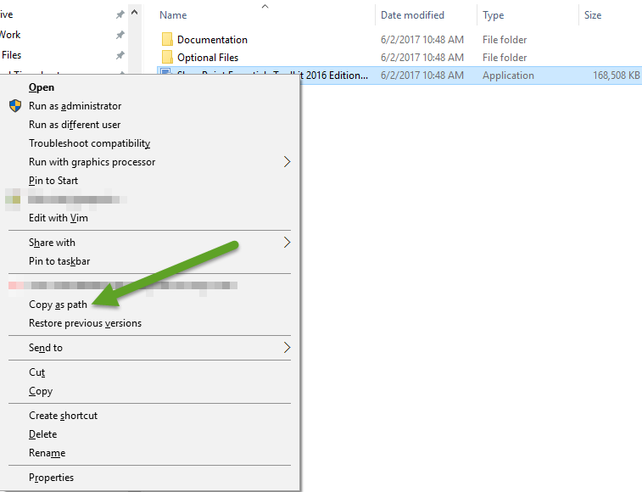

1. Open the Command Prompt as a Local Administrator
2. Paste into the Command Prompt window by Right Clicking->Paste
3. Use one of the switches above to install the SharePoint Essentials Toolkit (example below)
4. Press Enter to execute silent installation

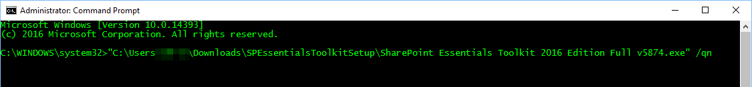

**NOTE:**

On Windows Vista and above, in order the install the package silently the installation package should run as a Local Administrator (elevated). This can be achieved by using the "Run as administrator" menu option, by default, the installer will try to run elevated and UAC will prompt the user if needed to input Local Administrator credentials.

## Troubleshooting Installation

In the event you see installation errors. You can review installation verbose logging in the path below

CurrentUser\AppData\Local\Temp\MSI*.LOG

CurrentUser\AppData\Local\Temp\MSI*.TMP

The file will being with MSI and end with .LOG or .TMP

## MSI Package

If you require the MSI package file, you can download the package here:

**MSI Package**

[https://apps.Cognillo.com/appupdates/essentials/SharePointEssentialsToolkitSetupMSI.zip](https://apps.qipoint.com/appupdates/essentials/SharePointEssentialsToolkitSetupMSI.zip)

**Example Usage:**

msiexec.exe /i "<Path>\SharePointEssentialsToolkitSetupMSI.msi" /passive

msiexec.exe /i "<Path>\SharePointEssentialsToolkitSetupMSI.msi" /quiet

Alternatively, you can use the steps below to extract it from the EXE:

Steps:

1. Download and extract the zip package to a location where you will execute the installation from client machine(s)
2. Hold SHIFT and Right Click on the installer executable, ‘SharePoint Essentials Toolkit Edition Full v****.exe’ (**** being the current version)
3. On the menu, click ‘Copy as Path’



1. Open the Command Prompt as a Local Administrator
2. Paste into the Command Prompt window by Right Clicking->Paste
3. Use the /extract switch to start the file extraction

Example: "C:\Downloads\Cognillo\SharePoint Essentials Toolkit ****.exe" /extract

1. You should see something like below:

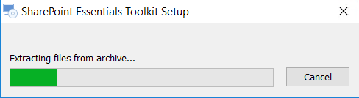

1. The MSI package will be located in the user AppData directory:  
   "C:\Users\bob.smith\AppData\Roaming\Cognillo\SharePoint Essentials Toolkit 6.9.2.0\install\D01ACCD\SharePoint Essentials Toolkit - Office.msi"   
   You can use the /qb switch to install silently using .msi package  
   **Example**:   
   msiexec /i "C:\Users\bob.smith\AppData\Roaming\Cognillo\SharePoint Essentials Toolkit 6.9.2.0\install\D01ACCD\SharePoint Essentials Toolkit - Office.msi" /qb SETUPEXEDIR=1

**Important:** *“SETUPEXEDIR=1”* is required for the command line execution to work.

## Checking for Program Updates

* Click “Check for Updates” from the application, or from the Start Menu
* The tool will periodically/automatically check for updates and prompt you if you want to install them. This requires an internet connection.
* You can obtain updates in one of 2 ways:
  1. Click ‘Check for Updates’ from the tool
     + The computer needs access to this path to get updates: [https://apps.Cognillo.com/appupdates/essentials/updates.txt](https://apps.qipoint.com/appupdates/essentials/updates.txt)
  2. Subscribe to update emails to get a download link when an update is available
     + Go to our website and navigate to the SharePoint Essentials Toolkit product page.
     + Click the ‘Subscribe to updates’ button

## Disable Checking for Program Updates

You can do this in several ways, listed below.  
However, we do not have a single command line to disable the updater. It requires user action, see below. You could automate using script if you modify the ‘ini’ file below (option 2) using command line.

To disable Auto-Update check:

1. Using the Windows command line prompt, run this command on the machine as a Local Administrator to disable it for the user:  
   (NOTE: If multiple users are using the tool on the same machine, this must be run for each user you would like to disable updates for.)

“Check for Updates.exe /set autoupdatepolicy **Disable”**  
Options: Disable | Prompt | AutoAll | AutoCritical

1. Manually on desktop: Using command line to prompt user with UI From the computer where the program is installed, open the command prompt and run this command: "C:\Program Files (x86)\Cognillo\SharePoint Essentials Toolkit\Check for Updates.exe /configure [HWND]" The user will be prompted to configure the update settings  
   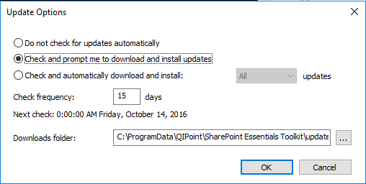
2. Manually by config file: There is a config file that you can modify to change the 'check frequency' to let's say 1000000 days. By default, the location of this config file is below: "C:\Program Files (x86)\Cognillo\SharePoint Essentials Toolkit\Check for Updates.ini"

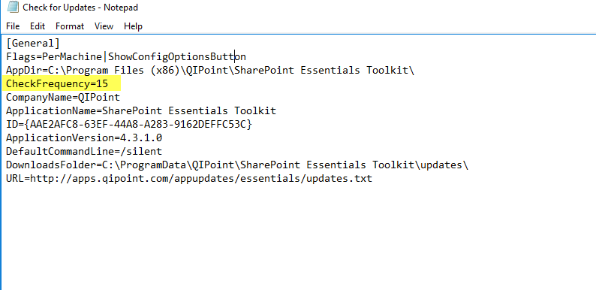

1. In order to block users from updating the software, it is necessary to block traffic to [https://apps.cognillo.com.](https://apps.cognillo.com./)  
     
   The full path the SharePoint Essentials Toolkit uses to update is:

<https://apps.cognillo.com/appupdates/essentials/SPEssentialsToolkitSetup.zip>

Users who subscribe to our automated email notifications for the update will also have this link:

<https://apps.cognillo.com/appupdates/essentials/SharePointEssentialsToolkitSetupMSI.zip>

Blocking (by DNS entry (redirect to invalid location) or firewall) ensure the user will not be able to update using links within the tool or manually from our website or email notifications.

## Disable Program Components/Features

In some cases, you may want to disable components from being available, such as to only provide certain functionality to users, like permissions reports, but nothing else.

You can disable/enable any of the following groups of features:

* Site & List Auditing
* Broken Link Manager
* Permissions Manager
* Content Manager
* Policy Manager

To do this, you will need to open the Settings.xml file (located at ‘My Documents\Cognillo\Config’) and modify the following settings, from True to False:

<ShowBLM>True</ShowBLM><ShowCMR>True</ShowCMR><ShowPLM>True</ShowPLM><ShowPRM>True</ShowPRM><ShowSLA>True</ShowSLA>

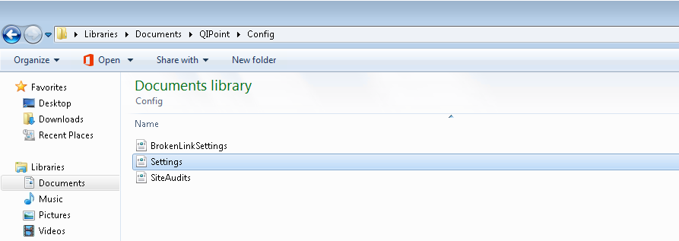

Setting a value to False will hide the component and its features. Setting a value to True (default) is to have the component and its features available.

## Cloud License Activation Process

(NOTE: This does not apply to per seat licenses, only Cloud/Concurrent model)

**License Activation Process:**

Our cloud license will attempt to activate the license on user machine the first time the user launches the application. It will not show a prompt after that unless there is something wrong with the license.

Once we set up the software package (with settings preconfigured), it will auto activate as below: (user will see below)

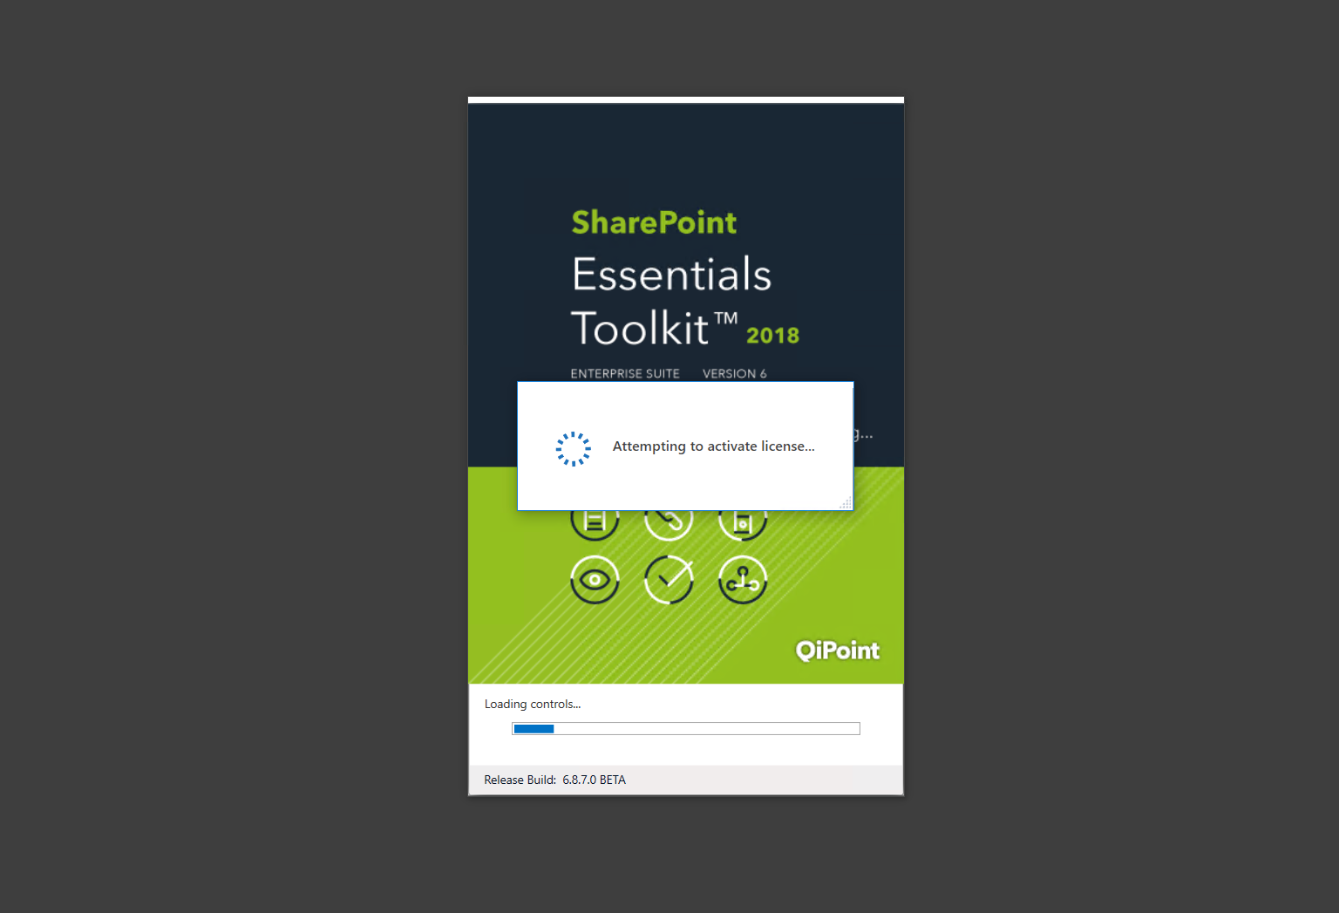

Upon successful activation, the user will see below: (They can click OK and continue using the software)

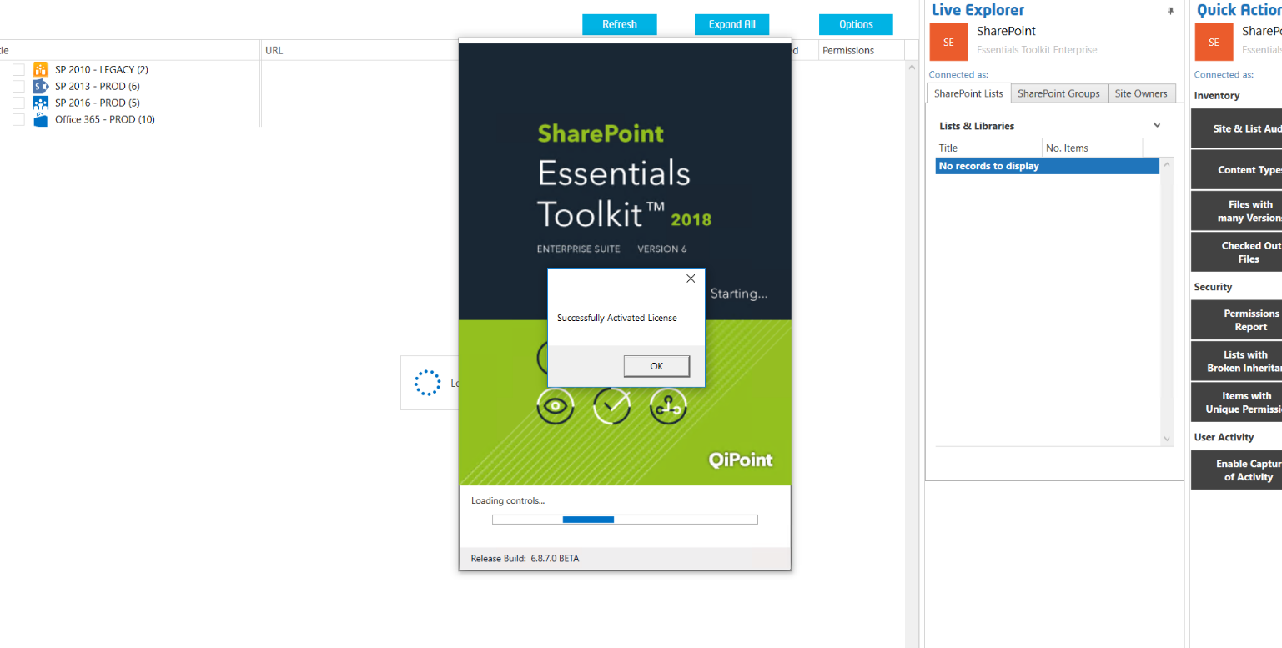

If there are no available licenses, this is the message that is shown:

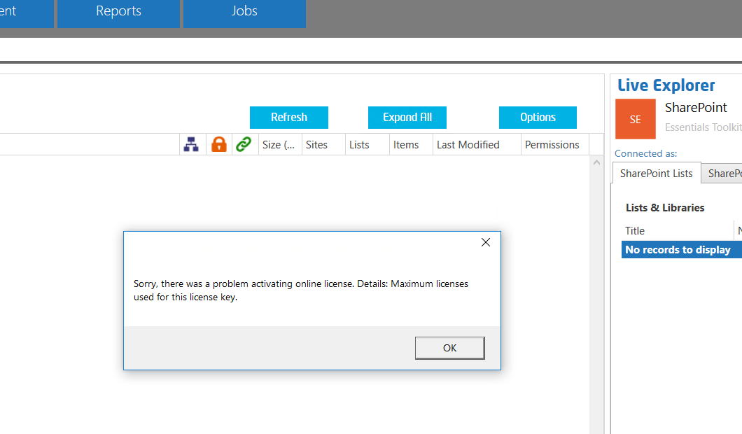

The license can be set to auto deactivate in the Application Settings (if no running jobs and no future scheduled jobs): (this could be preconfigured/packaged so it is set by default)

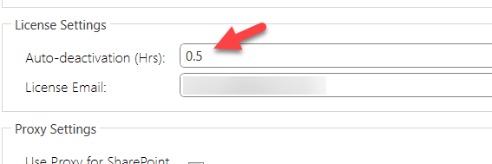

**Example values:**

3/1/2009 12:00:00 PM + 0.25 hour(s) = 3/1/2009 12:15:00 PM

3/1/2009 12:00:00 PM + 0.5 hour(s) = 3/1/2009 12:30:00 PM

3/1/2009 12:00:00 PM + 1 hour(s) = 3/1/2009 1:00:00 PM

3/1/2009 12:00:00 PM + 2 hour(s) = 3/1/2009 2:00:00 PM

Or user could manually release license by clicking ‘Deactivate’:

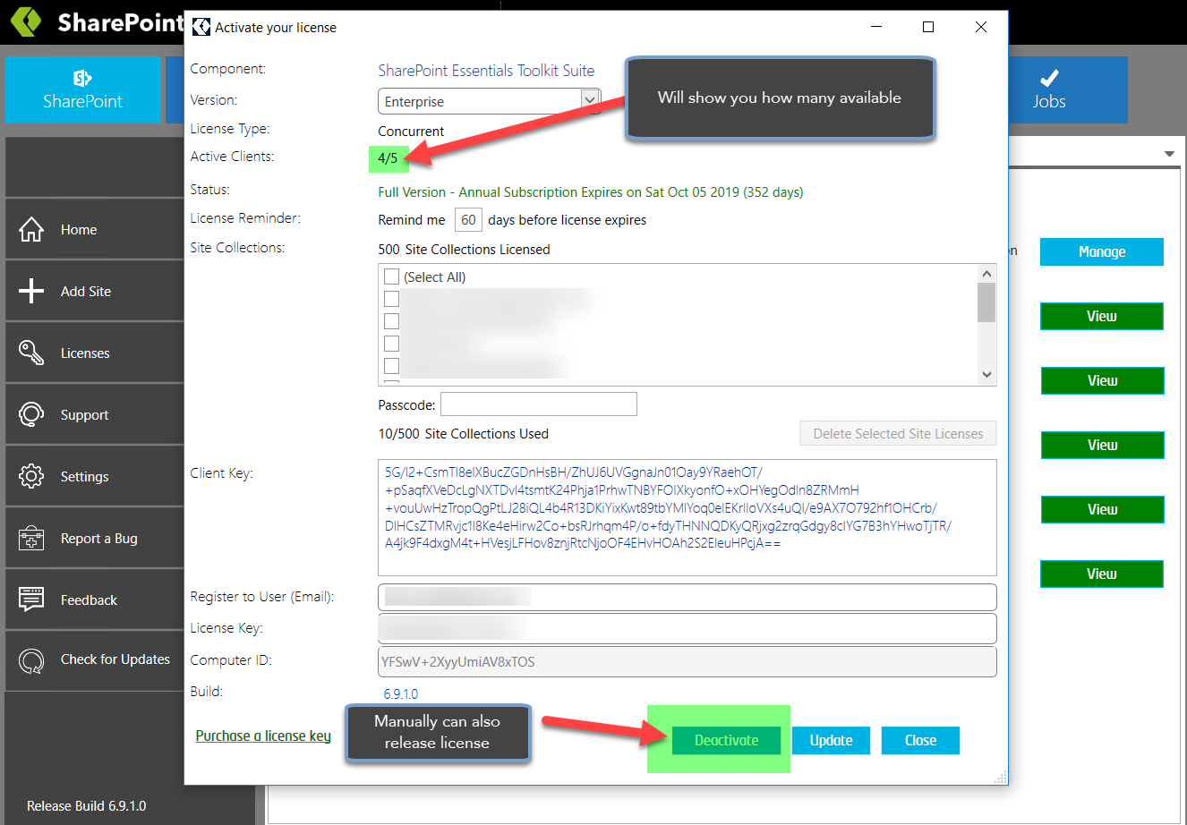

If the cloud license is currently in ‘Deactivated’ state, and the user attempts to run a new job, the user will be prompted automatically to obtain a cloud license:

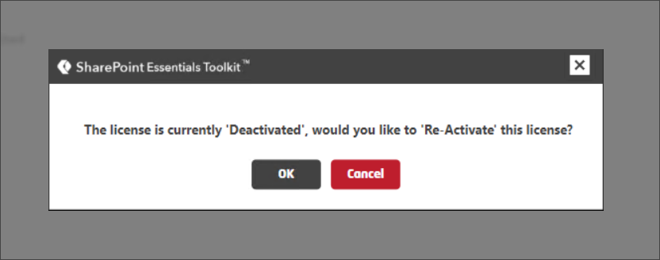

## Reports, Logs and Configuration File Directory Location

* By default, configuration files and reports are created and stored in the following path:

%SystemDrive%\Users\%username%\Documents\SPEssentials\

**Example:** C:\Users\bsmith\Documents\ SPEssentials\

* The path to the reports and logs can be changed in the application Settings
* The default configuration directory path can be changed by following the instructions below under **Manage and Change the Default Cognillo directory**.

## Shared Machines

Multiple users can use the same machine (‘server’) with this tool. However, the Scheduled Jobs will be visible/shared (and listed) for all users on the same machine.

### Licensing

An End User License entitlement is required per user (even if on the same machine and/or even if using a shared account) in order to be compliant with our license and technical support terms.

### Shared Reports and Configuration

To have all users that log onto the machine, share the same Site Collections, you need to use the steps below in section “Manage and Change the Default Cognillo directory” to change the default path to a central path for all users, such as D:\Cognillo\.

### Each User has Separate Reports and Configuration

By default, all users will have Site Collections listed separately from other users that log onto that machine. The configuration will also be separate for each user. By default, the report and config data are stored in each users “My Documents” folder under “SPEssentials”.

## Mapped Home Directories / Network Shares for Storing Reports

If the Report Path is on a network share, the Login Account used for the Windows Service “SharePoint Essentials Service”, must have an appropriate account that has Read/Write access to the network share. By default, the Report path is “<My Documents>\Cognillo”.

## Manage and Change the Default Cognillo directory

You can change the default Cognillo deployment directory from the default path of

%SystemDrive%\Users\%username%\Documents\SPEssentials\

after installation. The default path is set to the machine environment variable %MYDOCUMENTS%.   
To check this value on a Windows machine, you can use this PowerShell command below:

[Environment]::GetFolderPath("MYDOCUMENTS")

Which is equivalent to

Environment.GetFolderPath(Environment.SpecialFolder.MyDocuments)

This is the default path where the Cognillo directory will be deployed.

You can modify the default path by:

1. Install the SharePoint Essentials Toolkit
2. Navigate to the installation folder, by default it is:
   * C:\Program Files (x86)\Cognillo\SharePoint Essentials Toolkit

OR

* + C:\Program Files\Cognillo\SharePoint Essentials Toolkit

1. Locate the file named ‘ConfigPath’
2. Open this file and you can change the contents to one of the below values:
   * MyDocuments
     1. This is the default value
     2. Equivalent to %SystemDrive%\Users\%username%\Documents
   * LocalApplicationData
     1. Equivalent to %SystemDrive%\Users\%username%\%AppData%\Local
   * CommonApplicationData
     1. Equivalent to %SystemDrive%\%ProgramData%\
   * CommonDocuments
     1. Equivalent to %SystemDrive%\Users\Public\Documents\
   * [FilePath]
     1. [FilePath] is a custom path you can specify, such as G:\Data\SharePoint Apps\

## Variables in the ConfigPath

(SET Version 7.5.5.0 and higher)   
You may use %username% as a variable in the path string value. This value will be replaced with domain-username of user who launches the program at run-time (to correctly capture current user).

**NOTE:** This will only work if the path is a custom path ([FilePath] above).

Examples  
Logged in user name = MYDOMAIN\bob.smith

**Example 1**  
If we set the path to

\\share\applications\SET%username%\test

Then the result should be

\\share\applications\SET\MYDOMAIN-bob.smith\test

**Example 2**  
If we set the path to  
\\share\applications\SET\%username%

Then the result should be  
\\share\applications\SET\MYDOMAIN-bob.smith

## Anti-Virus, Offline Sync Folders (i.e. Google Drive, OneDrive, Drop Box, etc) and Performance

Antivirus programs that have on-access scanning may adversely affect the performance of this tool. There are several files that this tool creates and uses to operate correctly. We recommend reviewing these files and adding them to the on-access exclusions in order to allow the program to read and write to these files efficiently. Please consult with your Network Administrator to ensure this does not violate policies and you may contact us further information on how to do this or what these files are used for.

If you are using OneDrive, Google Drive, Drop Box or any other offline syncing program, please ensure the directories below are excluded or the offline syncing is turned off when using the tool. Offline syncing when the tool is trying to access configuration and report files may cause unexpected results.

### Anti-virus & Offline Sync Exclusion locations:

The following directories need to be excluded from on-access scanning (such as for anti-virus or offline syncing applications). Failure to do so will result in sub-optimal application performance and cause longer running jobs.

**IMPORTANT:** **You must also exclude subfolders of directories below**.

* <My Documents>\Cognillo
* C:\Users\UserName\AppData\Local\Temp\Cognillo
* C:\ProgramData\Cognillo

# Setup & Configuration

## Global Settings

To change the configuration options for the application:

1. From the Top Navigation, click on the “SharePoint” button
2. From the Left Navigation, click “Settings”

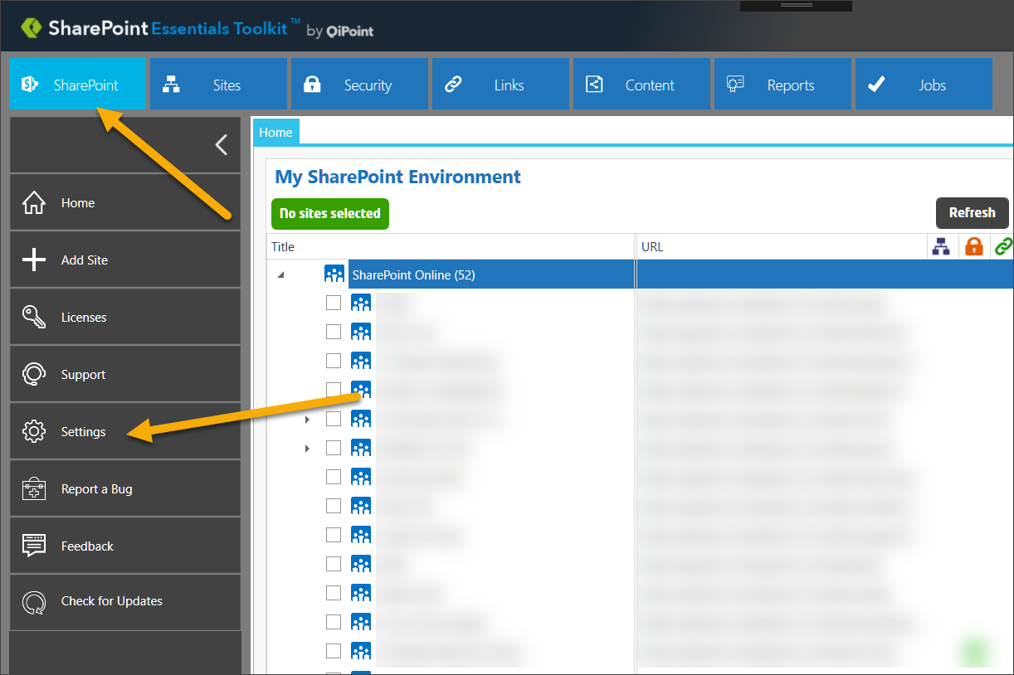

1. The following dialog will appear:

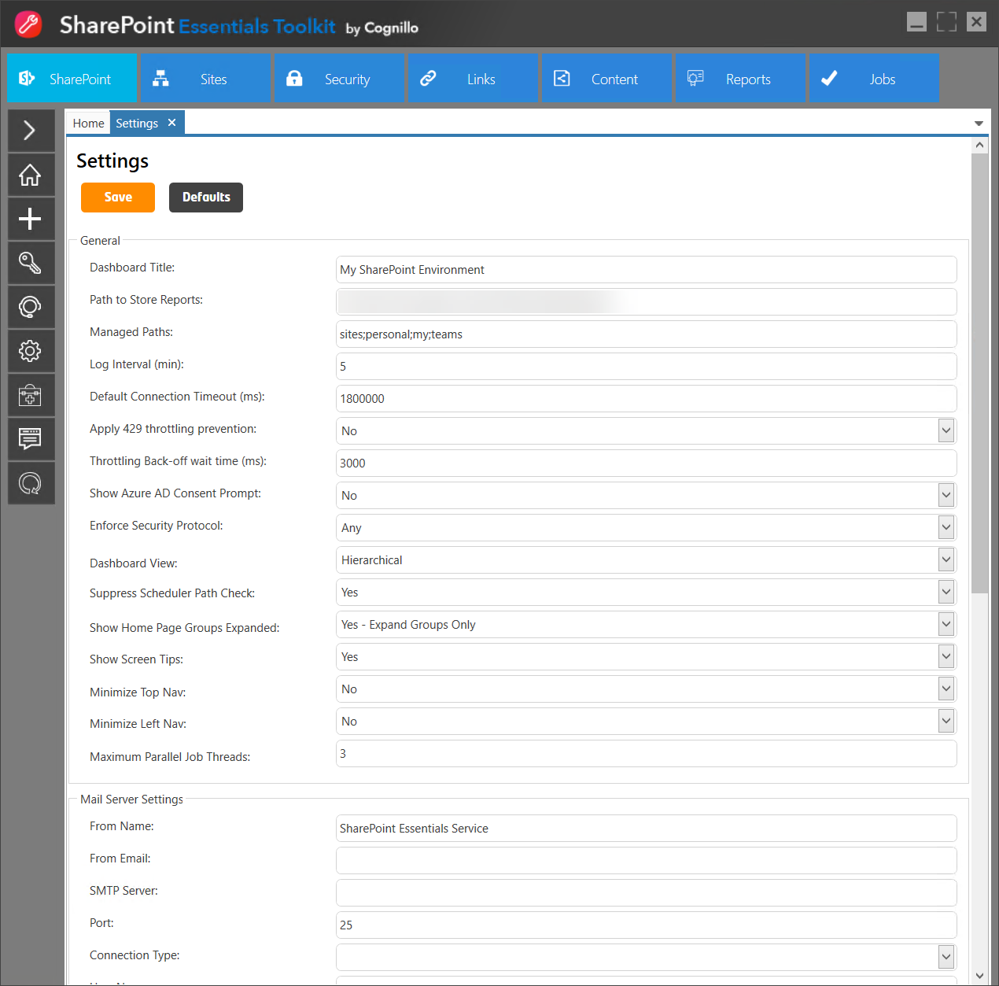

*TIP: You can use ‘minimal view’ by clicking the SharePoint Essentials Toolkit icon on top left.*

1. Complete the form or click the “Save” button. The next section will provide descriptions of the fields. “Defaults” will reset all values to the system defaults.

### General Settings

TIP: All settings can be pushed out to clients (pre-populated) using the Settings.xml file.

Dashboard Title

This is the label that appears on the Home page dashboard. This is only cosmetic and does not affect reports or jobs.

Path to Store Reports

This is where the reports and logs will be stored. Sub folders such as “Sites” and “Links” will automatically be created at this path, all reports will be stored here, organized in Job folders. The default is “My Documents\SPEssentials\Reports\”.

Managed Paths

Enter all SharePoint managed paths used. This is used for the tool to understand how site paths are used in your environment.

As this tool was designed for Site Owners/Site Collection Administrators and not Farm Administrators, users may not have access to Web Application level settings for the tool to grab this programmatically, so it is a manual setting. This can be pre-populated from the Settings.xml file.

Log Interval (min)

This value is used to determine the frequency of logs written in multi-site jobs and also in scheduled jobs. It is safe to decrease this value but may have an impact on report run-time performance.

Default Connection Timeout (ms)

This is the default timeout for connecting to sites, lists and retrieving information such as Site or list settings or permission data. Normally this does not need to be changed. The default is 180,000 ms (180 seconds).

Apply 429 Throttling Prevention

This option is used to prevent session throttling (mostly used for SharePoint Online environments). A log message will appear in the logs. If throttling is detected (HTTP Response of error 429), the tool waits and retries the last operation after specified wait time (does not skip unless passes 8 attempts).

Throttling Back-Off Wait Time (ms)

This option is used to set the delay if a 429 or 503 is response (from SharePoint) detected. This requires the option above “Apply 429 Throttling Prevention” to be turned on. The default is 3000 ms (3 seconds).

Show Azure AD Consent Prompt

(Only applies to Office 365 connections). If this option is enabled, and a user selects an option which requires Azure Active Directory (AD) access, the tool will prompt the user to get ‘consent’ for the application’.

The SharePoint Essentials Toolkit cannot query your organization’s Azure Active Directory without permission and must get permission from your Office 365 Global Administrator to allow it to make queries against Azure Active Directory, such as get Azure AD Group members.

This is a Microsoft requirement for any application to connect to Azure.

Example: If a user is using a SharePoint Online site and chooses to create a Permissions report and selects ‘Show Nested Permissions (Domain Groups)’ (see below), the SharePoint Essentials Toolkit needs to query Azure AD to get the members of domain groups. Once the user selects this option.

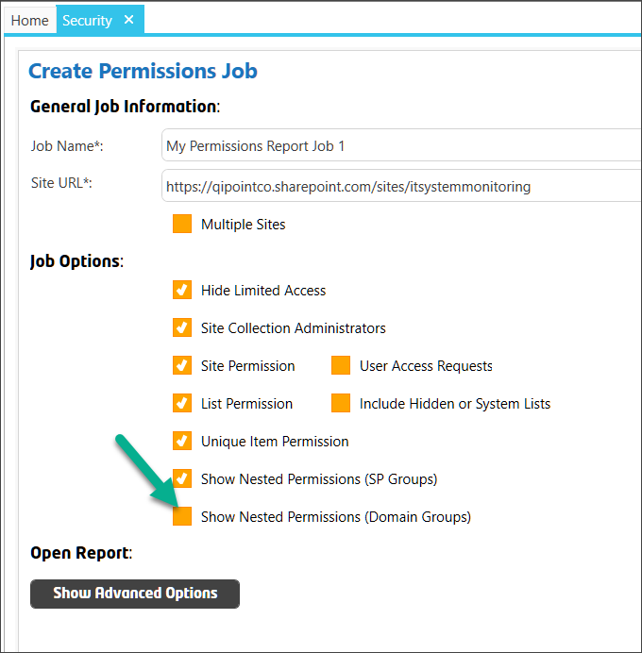

If this Setting is enabled, the user will see this message:

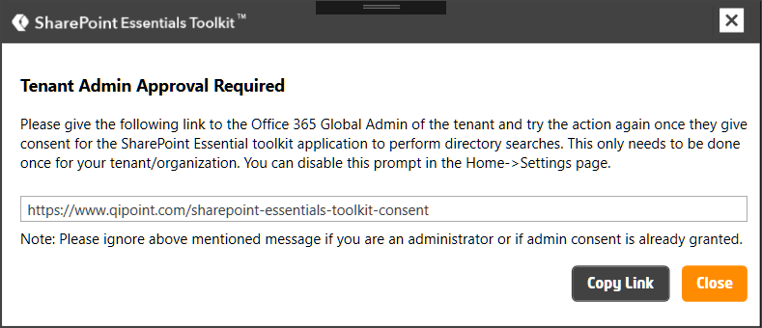

Once consent is provided, the user can disable this prompt in the settings. This option can also be turned off for all users by updating the Settings.xml file when deploying the tool.

Dashboard View

“Hierarchical” will display sites in a hierarchy with multiple levels. Currently this is the only view option available. “Flat” view has been removed which was in previous versions of this tool.

Show Home Page Groups Expanded

This relates to the option above. On the Home Page, the list of Sites are displayed in groups once you have performed a scan. This will set the behavior of group and site expansion of the home page dashboard whenever it is loaded. For example, expanded sites will automatically be ‘opened’ on the home page dashboard vs. being collapsed and require clicking the plus sign to expand them.

Show Screen Tips

You can optionally turn off showing screen tips.

Minimize Top Nav

If this is turned on, the Top Navigation will be automatically minimized on startup.

Minimize Left Nav

If this is turned on, the Left Navigation will be automatically minimized on startup.

Maximum Parallel Threads

This setting is used when the user is running a job for more than 1 site at a time. When “Multiple Sites” is selected in a job, each site will run in a thread in an attempt to complete faster (vs. sequentially). Increasing this value will cause more memory to be used, CPU processing, and network connections. In some organizations, proxy servers may forcibly close the connection for threads waiting to connect. This value will be the maximum number of threads to run at one time.

Example, the value of 3: If user runs a job for 500 sites, the job will process no more than 3 at a time. When one job is complete, another thread will start automatically until 3 are running at once.

NOTE: For Permissions Manager, permission reports will run for the root Site Collection(s) first, in order to capture and cache SharePoint Groups and Domain Groups found in the Site-level Permissions. SharePoint Groups and Domain Groups found after that will be added to cache for other threads to use in order to reduce calls to Azure AD, on-premises AD and calls to re-fetch repeat SharePoint Groups and members.

### Mail Server Settings

From Name

This is the display name that appears in the emails (‘From’) used to send the reports.

From Email

This is the email address used to send the reports.

SMTP Server

This is the FQDN (Fully Qualified Domain Name) of the SMTP mail server responsible for relaying emails. Example: smtp.mycompany.com

Port

This is the port used when sending email.

Connection Type

This is the authentication protocol used to communicate with the SMTP server when sending emails.

User Name

This is the username that is passed as part of the credentials when sending email as ‘From Email” address.

Password

This is the password that is passed as part of the credentials when sending email. It should correspond with the “User Name” above

### License Settings

Auto-deactivation (Hrs)

(Only applies to CONCURRENT/Cloud licenses) This option can be used to automatically deactivate client endpoint license after a specified number of hours. This can be a whole number or decimal value for minutes. The program does not need to be open for this feature to work, however the machine must be on, and the Windows Service ‘SharePoint Essentials Service’ (or may be listed as ‘SharePoint Essentials Service’ depending on product version) must be running for this option to work. After N hours, the product will check if there are any running jobs or any future scheduled jobs, if there are none, it will automatically release the user license back into the pool to allow another user to ‘use’ it.

License Email

This is the email address that will be registered during License Activation (ONLINE Activations only). This email address will populate all of the License screens under the License page. NOTE: Offline activations require user to send us the email address associated with machine/user to be licensed.

Disable Scheduler Recurring (hidden – only can be changed via Settings.xml file)

This setting is hidden and can only be accessed via Config\Settings.xml. This is used to disable the Scheduled Jobs recurring job options. This is useful when using the ‘Auto-deactivation so that users cannot schedule recurring jobs which will ‘hold onto’ licenses.

### Proxy Settings

Use Proxy for SharePoint Connection

Select this option if you are using a Proxy Server. Turning on this option will cause the tool to use Proxy information set below for SharePoint connections. If you are using Broken Link Manager, turning this option on will cause the tool to use the Proxy information for SharePoint and all Links found. If you need to turn off Proxy for SharePoint only or specific URLs (such as Intranet URLs), add them to the ‘Proxy Exceptions’ section below.

Use Proxy for License Activation

Select this option if you are using a Proxy Server. Turning on this option will cause the tool to use Proxy information set below for the Online License Activation only.

Proxy Server

If you are using a Proxy Server, you must enter the Proxy Server IP address or host name (do not enter http or https, this value should be the host name or IP address of the proxy server).

Proxy Port

If you are using a Proxy Server, you must enter the Proxy Port here.

Proxy Username

If you are using a Proxy Server, and the Proxy Server requires authentication, enter the Proxy username here. If you are using a Proxy Server with anonymous authentication, then leave this field blank.

Proxy Password

If you are using a Proxy Server, and the Proxy Server requires authentication, enter the Proxy password here. If you are using a Proxy Server with anonymous authentication, then leave this field blank.

#### **Proxy Server Notes:**

It is REQUIRED that the Internet Explorer browser proxy server settings are also set.

If you require use of a Proxy Server only for external links and NOT intranet/local SharePoint URLs/connections, such as for use with SharePoint Broken Link Manager, you would first set up the Proxy Server settings as below:

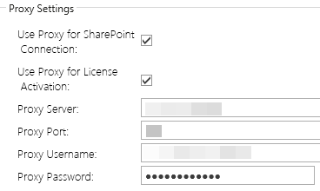

And then, second, add the SharePoint domain URLs to the Exceptions list so that they do NOT use the proxy settings:

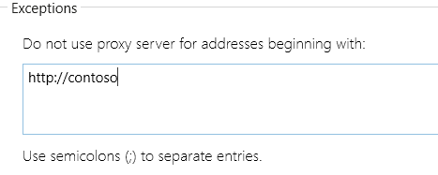

Use * as wildcards. In some cases, you will need to also enter this information (URL exceptions) into the Internet Explorer settings as well.

**Other**

Defaults (button)

You may reset values to defaults by clicking the “Defaults” button.

Don’t forget to click Save!

## Sample Network Diagram

You may use below as an example network diagram for your documentation. This is an example of using our product within the company network as ‘servers’ to manage Office 365 SharePoint Online tenant(s).

## Push Settings (including license key) to Multiple Endpoints (client machines)

If you have more than one user who needs to install this tool, you can optionally push out the settings to their machines and also auto-activate the licenses for them.

The following parameters are available to be pushed out to the client endpoints:

(For descriptions of these options, see ‘Global Options’ section above.)

* <AutoDeactivationHrs></AutoDeactivationHrs> Value: Decimal
* <ConnectionType></ConnectionType> Value: Plain SMTP, Extended SMTP, SSL, TLS
* <DashBoard></DashBoard> Value: Alphanumeric
* <DisableSchedulerRecurring></DisableSchedulerRecurring> Value: True, False
* <FromEmail></FromEmail> Value: Alphanumeric
* <LicenseEmail></LicenseEmail> Value: Alphanumeric
* <LogInterval></LogInterval> Value: Integer
* <ManagedPaths>sites;personal;my;teams</ManagedPaths> Value: Alphanumeric
* <SmtpFrom>Sharepoint Essentials Service</SmtpFrom> Value: Alphanumeric
* <smtpUserName></smtpUserName> Value: Alphanumeric
* <SmtpPassword></SmtpPassword> Value: Alphanumeric (Must be encrypted by saving from Settings page in UI)
* <SmtpServer></SmtpServer> Value: Alphanumeric
* <Port>25</Port> (SMTP Email Port) Value: Integer
* <ProxyLicense></ProxyLicense> (Use Proxy for License Activation) Value: True, False
* <ProxySharePoint> </ProxySharePoint> (Use Proxy for SharePoint) Value: True, False
* <ProxyPassword></ProxyPassword> Value: Alphanumeric (Must be encrypted by saving from Settings page in UI)
* <ProxyPort></ProxyPort> Value: Integer
* <ProxyServer></ProxyServer> Value: Alphanumeric
* <ProxyUsername></ ProxyUsername> Value: Alphanumeric
* <ReportDirectory></ReportDirectory> Value: Alphanumeric
* <ShowScreenTips>Yes</ShowScreenTips> Value: Yes, No
* <TimeOut>360000</TimeOut> (SharePoint Connection default timeout) Value: Integer
* <VLK_SET></VLK_SET> (Autoactivation: VLK/Volume License Key for SharePoint Essentials Toolkit Enterprise Suite)
* <VLK_PRM></VLK_PRM> (Autoactivation: VLK/Volume License Key for SharePoint Permissions Manager Enterprise)
* <VLK_BLM></VLK_BLM> (Autoactivation: VLK/Volume License Key for SharePoint Broken Link Manager Enterprise)
* <VLK_CMR></VLK_CMR> (Autoactivation: VLK/Volume License Key for SharePoint Content Manager Enterprise)
* <VLK_PLM></VLK_PLM> (Autoactivation: VLK/Volume License Key for SharePoint Policy Manager Enterprise)
* <VLK_SLA></VLK_SLA> (Autoactivation: VLK/Volume License Key for SharePoint Site and List Auditing Enterprise)
* <ShowBLM>true</ShowBLM><ShowCMR>true</ShowCMR><ShowPLM>true</ShowPLM><ShowPRM>true</ShowPRM><ShowSLA>true</ShowSLA> Value: True or False
* <ShowCustomWindow></ShowCustomWindow> Value: Yes or No

**NOTE:** If the Settings.xml has attribute i:nil="true", this will cause the value to be ignored by the tool. The values must be set using XML format: <AutoDeactivationHrs></AutoDeactivationHrs> not <AutoDeactivationHrs i:nil="true"></AutoDeactivationHrs>.

1. Install the SharePoint Essentials Toolkit
2. Open SharePoint Essentials Toolkit
3. Go to Home->Settings
4. Enter Global Settings including passwords so that they are encrypted, click Save
5. Close SharePoint Essentials Toolkit
6. Navigate to My Documents\Cognillo\Config
7. Open the Settings.xml file
8. Verify and modify any other settings as needed
9. Save this Settings.xml to be used to push out to clients

You can push this file out to clients using PowerShell or Command Line / scripts.

### Automatic Online Activation

You can enter the VLK (Volume License Key) in the Settings.xml and push the configuration to each client. The first time they launch the application, the tool will attempt to activate automatically.

This feature requires an internet connection, a value for <LicenseEmail> and <VLK_ProductName> in order to work.

Automatic Online Deactivation (Enterprise Cloud Licenses)  
When setting ‘AutoDeactivationHrs’ value, here are some examples:  
**Example values:**

* 3/1/2009 12:00:00 PM + 0.25 hour(s) = 3/1/2009 12:15:00 PM
* 3/1/2009 12:00:00 PM + 0.5 hour(s) = 3/1/2009 12:30:00 PM
* 3/1/2009 12:00:00 PM + 1 hour(s) = 3/1/2009 1:00:00 PM
* 3/1/2009 12:00:00 PM + 2 hour(s) = 3/1/2009 2:00:00 PM

## Configuring for Office 365 Modern Authentication

The SharePoint Essentials Toolkit (v9.8.1.0 and higher) supports Office 365 Modern Authentication.

This may be a requirement in your organization if you have this configured to block access:

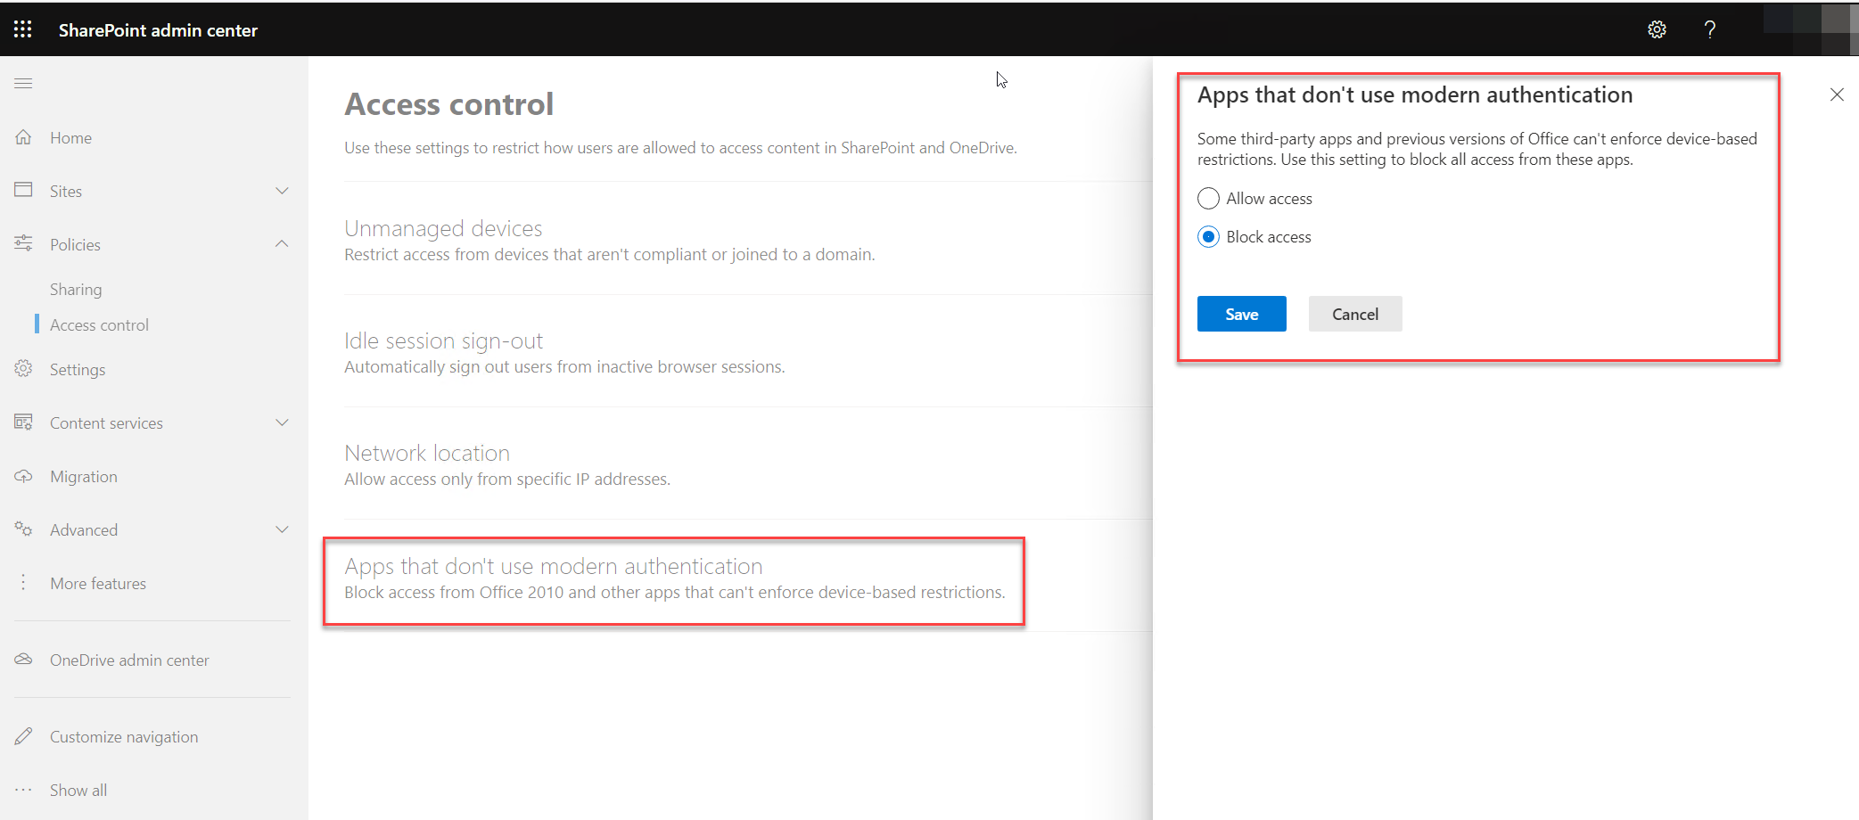

To implement support for this, an Office 365 Global Tenant Admin must add the SharePoint Essentials Toolkit as a trusted application to the tenant in Azure Active Directory Enterprise Applications.

### Upgrade to SharePoint Essentials Toolkit v9.8.1.0 or above

1. Download and update to the latest version using one of these download links:
   * [Download SharePoint Essentials Toolkit Full](https://apps.cognillo.com/appupdates/essentials/SPEssentialsToolkitSetup.zip) (EXE)
   * [Download SharePoint Essentials Toolkit Full](https://apps.cognillo.com/appupdates/essentials/SharePointEssentialsToolkitSetupMSI.zip) (MSI)
2. In some cases, you may only need to use ‘Web Browser Authentication” and select “Use Modern Authentication” checkbox:  
     
   Graphical user interface, website

   Description automatically generated  
     
   **Please attempt this first**, if this does not work, continue using steps below. If this allows you to add sites/run jobs, you may skip all steps below.
3. The download includes a folder called "Optional Files", open it once the download has completed
4. Download the SharePoint Online PowerShell application from Microsoft: [Download SharePoint Online Management Shell from Official Microsoft Download Center](https://www.microsoft.com/en-us/download/details.aspx?id=35588)
5. Right click to "Run as Administrator" the application you downloaded: Microsoft SharePoint Online PowerShell,
   * Execute the file 'AzureAppRegistrationModernAuth.ps1', example below:
   * Type (without quotes)   
       
     "CD C:\path-to-folder-containing-AzureAppRegistrationModernAuth\"
   * Type (without quotes)   
       
     "./AzureAppRegistrationModernAuth.ps1"
6. The above should automatically add the SharePoint Essentials Toolkit to your tenant as an Enterprise Application.
7. As a Global Tenant Administrator, navigate to the Azure Active Directory portal admin center
8. Click Enterprise Applications
9. Locate the SharePoint Essentials Toolkit (Modern Authentication) application, click on it
10. Copy the Application ID from the tenant page below  
      
    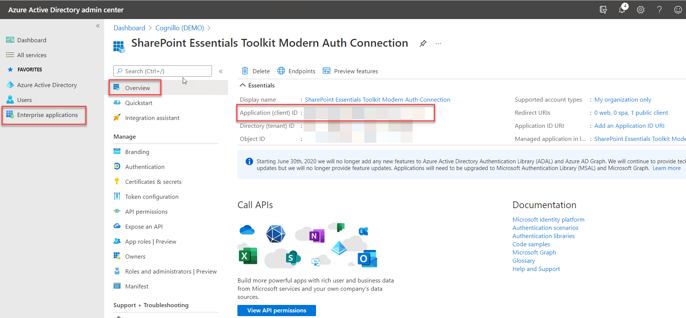
11. Install/upgrade if needed, and open the SharePoint Essentials Toolkit program
12. Click Settings and paste the Application ID into 'Cognillo Azure App ID' field  
      
    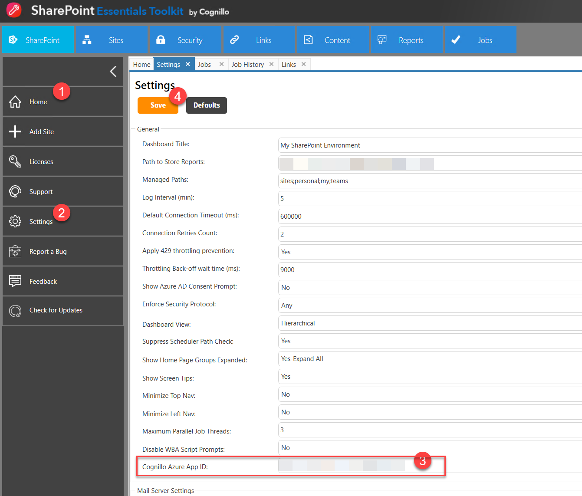
13. Click Save
14. You should now be able to choose Office 365 (Modern Auth) from the Credential Type to connect to your environment.

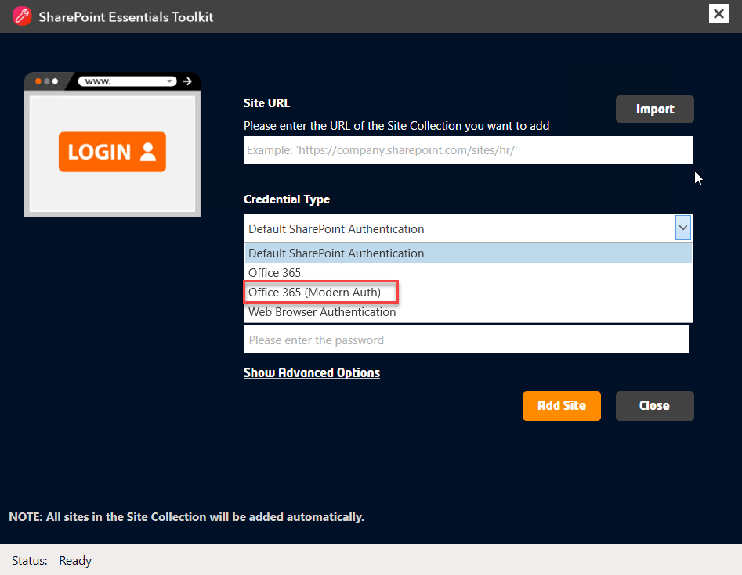

## Credentials & Passwords

The SharePoint Essentials Toolkit does not store Passwords as plain text, they will always be encrypted when saved/stored in the file system. Passwords are also encrypted when being transmitted to SharePoint Online / Office 365 or SharePoint on-premises servers.

### Where are Credentials stored?

When you Add a Site to the SharePoint Essentials Toolkit, the credentials used to make the SharePoint connection may be stored in the local machine where the SharePoint Essentials Toolkit is installed. These credentials are stored only if the user selects “Remember Credentials” checkbox option.

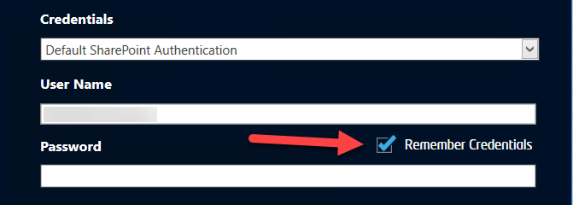

#### Folder Location

By default, the folder location of any credentials is:

*“My Documents\Cognillo\Config\”*

This path may be changed by setting the path in Manage and Change the Default Cognillo directory

Depending on the connection type, due to the size of stored cookies, we have 2 files which can store the credentials. Depending on what is chosen in the Credential Type drop down.

#### SharePoint On-Premises or Office 365

If ‘Default SharePoint Authentication’ is used (SharePoint on-premises default) or ‘Office 365’:

The credentials are then stored in a file called “SiteAudits.xml”, full path would be:

*“My Documents\Cognillo\Config\SiteAudits.xml”*

Example below:

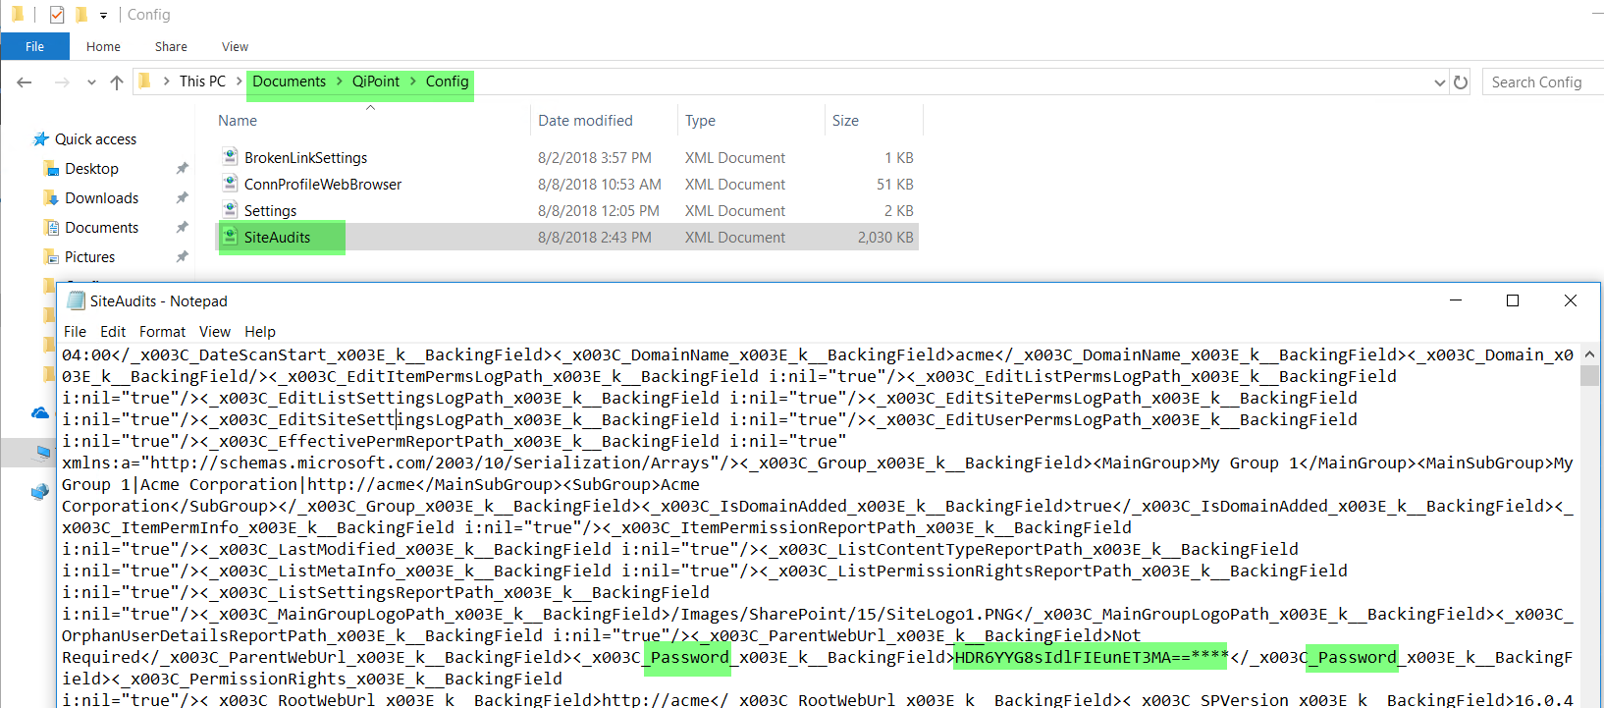

#### Web Browser Authentication

If ‘Web Browser Authentication’ is used:

The credentials are then stored in a file called “ConnProfileWebBrowser.xml”, full path would be:

*“My Documents\Cognillo\Config\ConnProfileWebBrowser.xml”*

We use FedAuth cookies to store credentials to connect to SharePoint when Web Browser Authentication is selected.

The FedAuth cookie is a cookie for the user's session. Also, inside the FedAuth cookie is a reference to the SAML token stored in SharePoint's token cache (i.e. on the server). This reference is so SharePoint can keep track of who the user is and what they can access.

Example below:

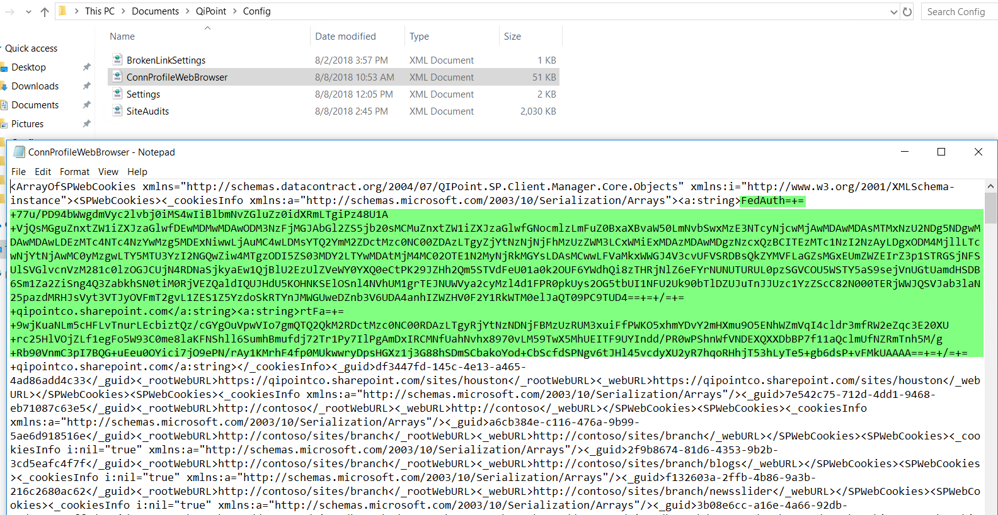

### How are Credentials stored?

All passwords are first encoded, then a passphrase is added from Cognillo programmatically, and a salt value is then added for extra security, then this value is encrypted using AES (also known as Rijndael) encryption with 256 bits key length. Encryption mode used is CBC (Cyber Block Chaining).

The encrypted value is finally then converted to a Base 64 encoded string to be stored.

If encryption fails or any part of the encryption process, the password is not stored.

### Changing Credentials

To change the login credentials for one or more Sites, click Home->Add Site to re-add the Site or Site Collection and click “Remember Credentials”.

If you add a root Site Collection, all sub sites will have the credentials updated with the new one. If you use the Import function for multiple Sites or Site Collections, all credentials for those sites will also be updated.

If you need to update credentials for multiple Site Collections, you can use ‘Add Site’ and import the Site Collections using Excel. Alternatively, you can also update credentials by Creating a bulk multi-threaded job for the Site Collections and enter new credentials to be used and select ‘Remember Credentials’.

Existing reports, logs and Scheduled Jobs will remain in-tact. The credentials will be updated and are encrypted using Strong Salted Encryption.

## Sub Site Changes

In case your list of subsites change, such as new ones are added or removed, you can ‘resync’ your subsites by clicking ‘Refetch Sites’ from the Home Page Dashboard.

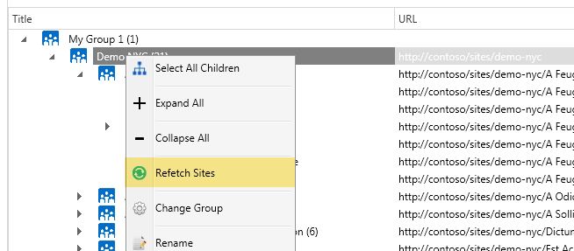

## Scheduler Service

This service is required to schedule audit jobs.

1. Open Windows Services (Control Panel->Administrative Tools->Services).
2. Locate the “SharePoint Essentials Service”.
3. Right click and start the service.   
   NOTE: If the service does not start, try changing the log on credentials to use your account to ensure it has adequate access to create and save scheduled job reports. This account requires edit rights to “C:\ProgramData\Cognillo”.

**IMPORTANT:** If the user directory is on a NETWORK Share, you must use a login account for this service that has appropriate access to the user My Documents folder on the network share. For example, change from the default Login Account ‘Local System’ to the user’s domain account.

## Custom Views - Copying from One User/Machine to Another

To copy a view from one user to another, please follow these steps:

1. Navigate to the SOURCE folder that contains the view you want to copy:

[source username]\Documents\Cognillo\Reports\[component name]\CustomViews

1. Copy the XML files that contain the views that you want to copy. They will have the name of the view in the filename.

For Example: a View with name ‘Links to Old Environment’ will have a filename of ‘ViewName_Links to Old Environment.xml’

1. Paste these files into the TARGET folder that you want to use these views

[target username]\Documents\Cognillo\Reports\[component name]\CustomViews

NOTE: You do not need to restart the SharePoint Essentials Toolkit program

1. Open a new Report and the view(s) should appear in the View drop down list!

# User Interface

## Navigation

The User Interface has the following areas:

1. Top Navigation
2. Left Navigation
3. Home Page Dashboard (Body)

Shown below:

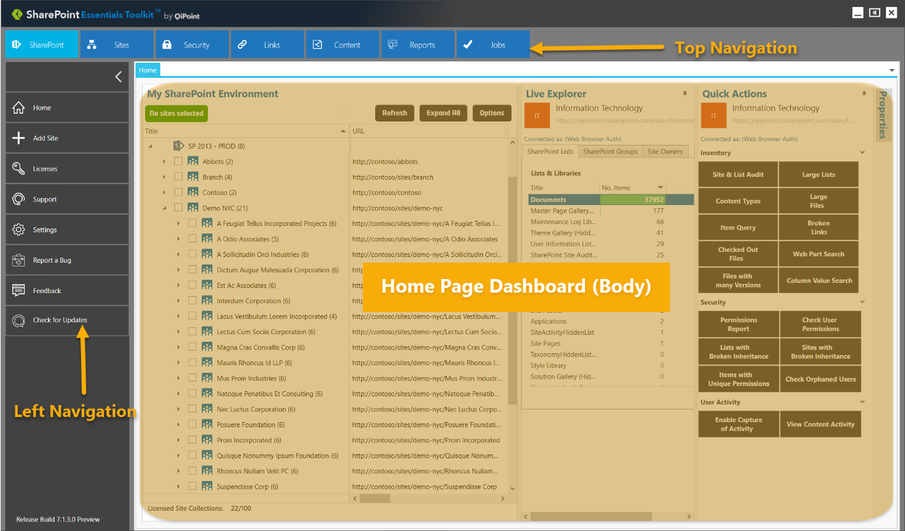

## Quick Views

You can maximize your viewing area by clicking the Cognillo logo on the top left

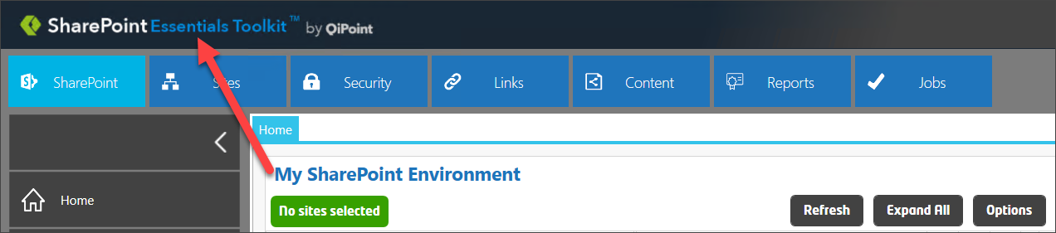

Below is the “Full View” setting, you can then restore the view by clicking the top left ‘down’ arrow to re-expand the navigational areas:

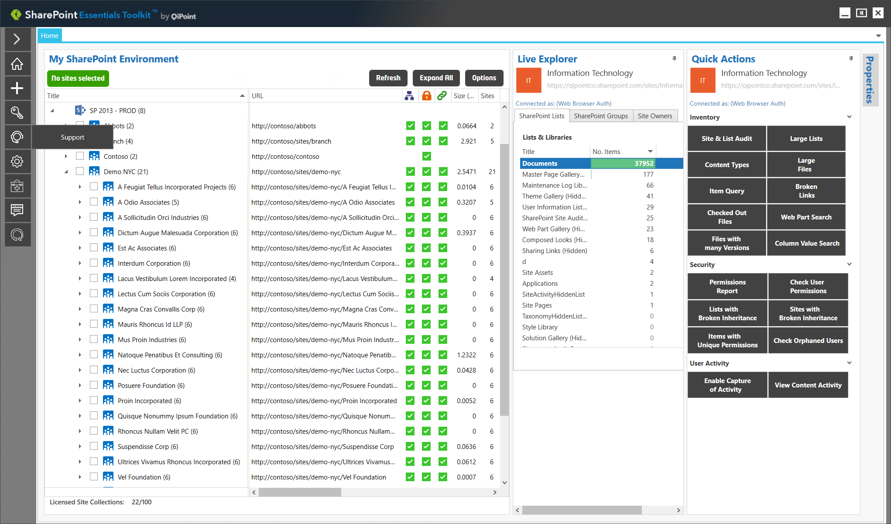

# Pinning & Unpinning Windows

You can increase your viewing area of windows by pinning and unpinning. To pin or unpin a window, click on the “Pin” icon  . This will expand or collapse the window/panel. 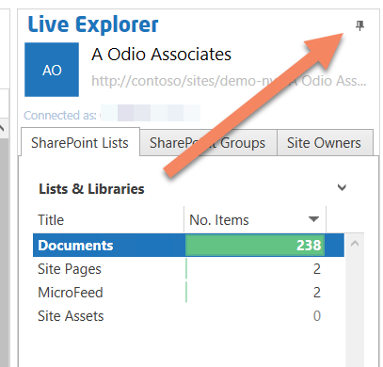

# Home Page Dashboard

The “Home Page Dashboard” is located on the home page and is used to organize and display information about the Sites that the user is managing. The dashboard also provides a quick way to execute tasks on a site by right clicking on them or using the Quick Actions panel.

You can get to the “Home Page Dashboard” by clicking on the “SharePoint” button in the Top Navigation or from any “Home” button in the Left Navigation.

NOTE: The dashboard will only show information once a scan is successfully completed on a Site. You can also click “Add Site” from the ribbon menu to add sites to the home page dashboard.

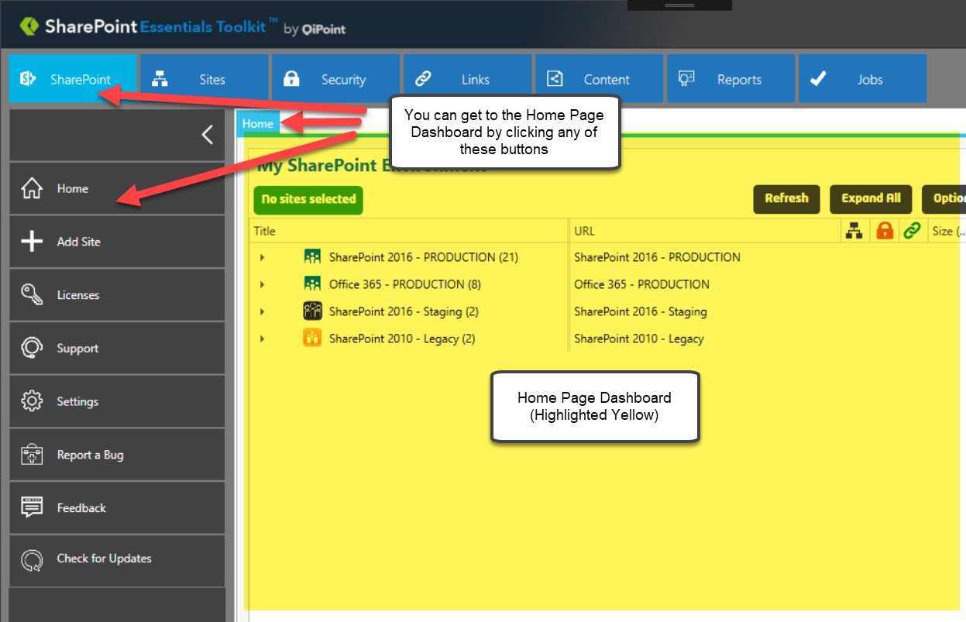

## Adding a ‘Managed’ Site Collection

1. Open the SharePoint Essentials Toolkit
2. Click “Add Site” in the Left Navigation  
     
   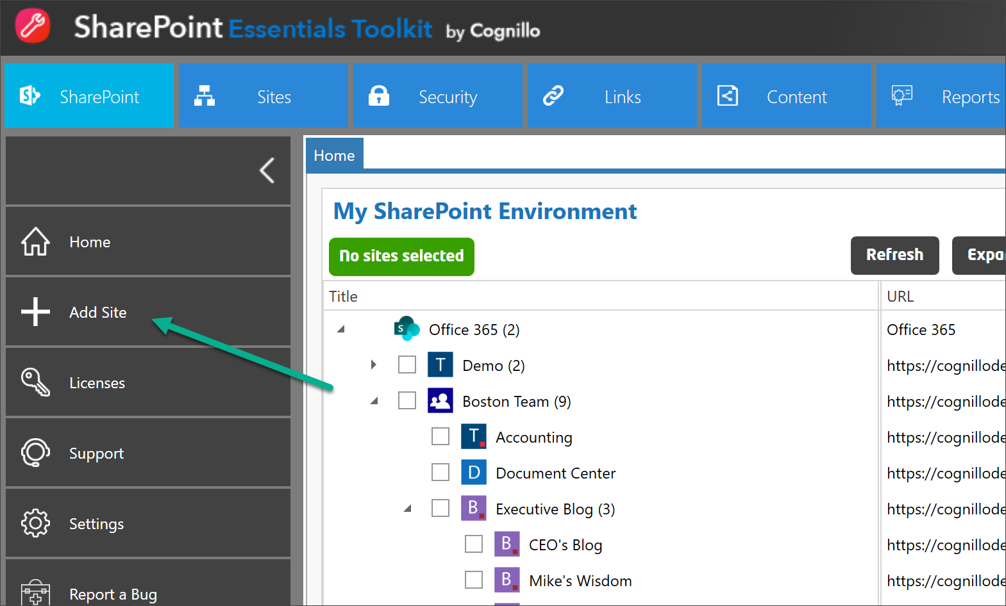
3. You will see the pop up window below to add the site collection, all subsites will automatically be added to the “Home Page Dashboard”

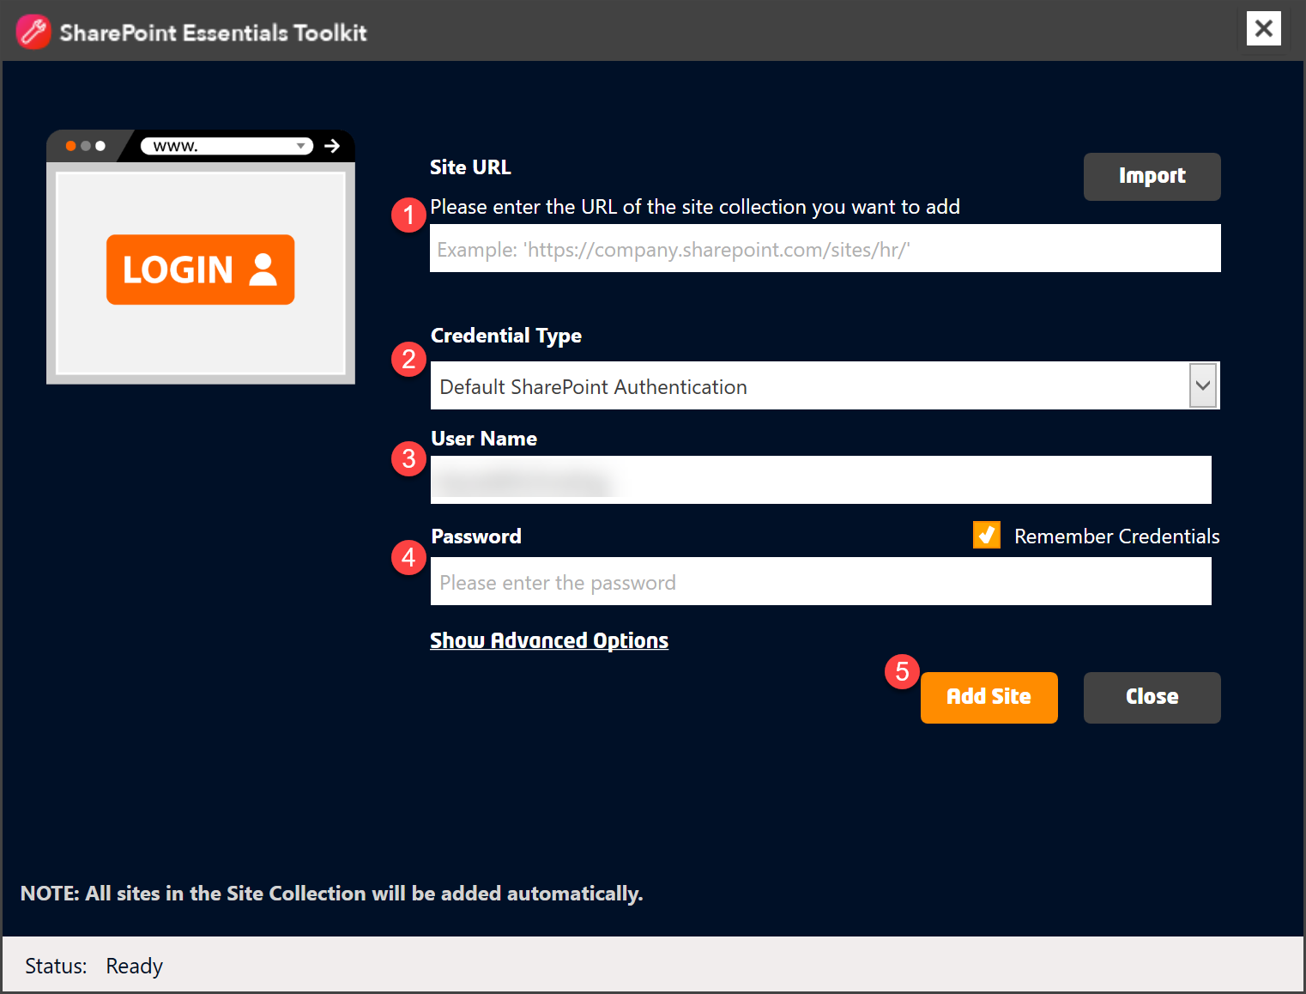

1. The tool will automatically add any subsites under that Site Collection that the account has access to

## Authentication Types

Below are descriptions for the authentication types that can be used to connect to your SharePoint environment.

### Default SharePoint Authentication

On-premises SharePoint only (NTLM, Kerberos)

### Office 365

Basic Office 365 authentication (Legacy)

### Office 365 (Modern Auth)

Office 365 Modern Authentication is based on ADAL (Active Directory Authentication Library) and OAuth 2.0. Also supports MFA (Multi-factor Authentication).

### Web Browser Authentication

Https authentication using Secure Cookies, supports MFA (Multi-factor Authentication), AD Federated environments (ADFS, LDFS), 3rd party authentication mechanisms (such as Okta or RSA SecureID).

## Import Multiple Sites to Dashboard

You can bulk import sites using one of two options:

1. “Advanced Options-> Retrieve all Sites from Web Application” – This requires the SharePoint Search service to be functional and active on the target environment. This will automatically retrieve all site collections from SharePoint and add them to the tool. The tool will attempt to get all Site Collections using the equivalent search command query WHERE “contentclass:STS_Site” to get site collection results.  
     
   Click “Show Advanced options”  
     
   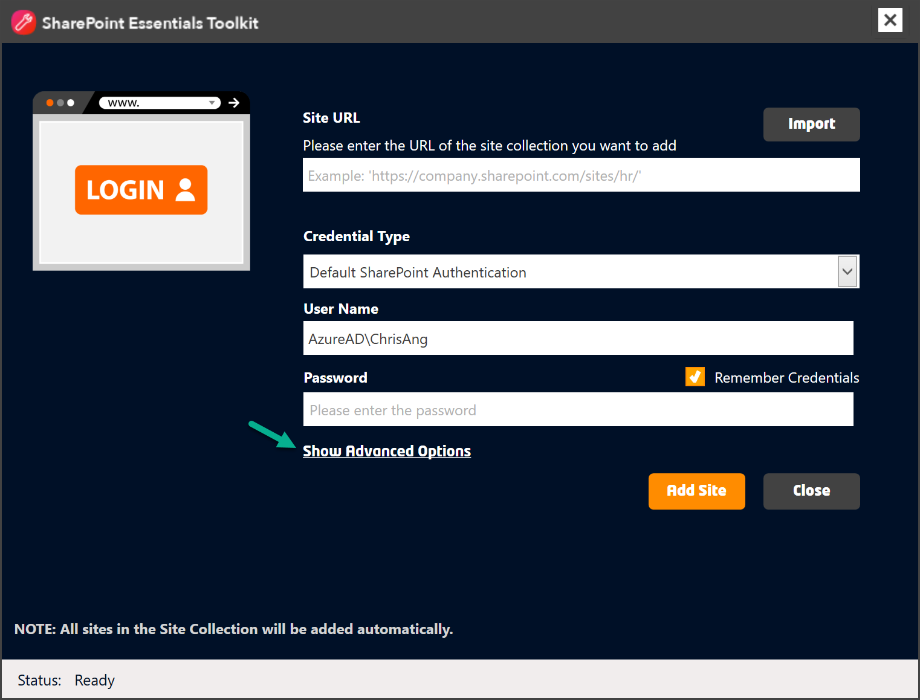  
     
   Complete the form as below and click “Add Site”  
     
   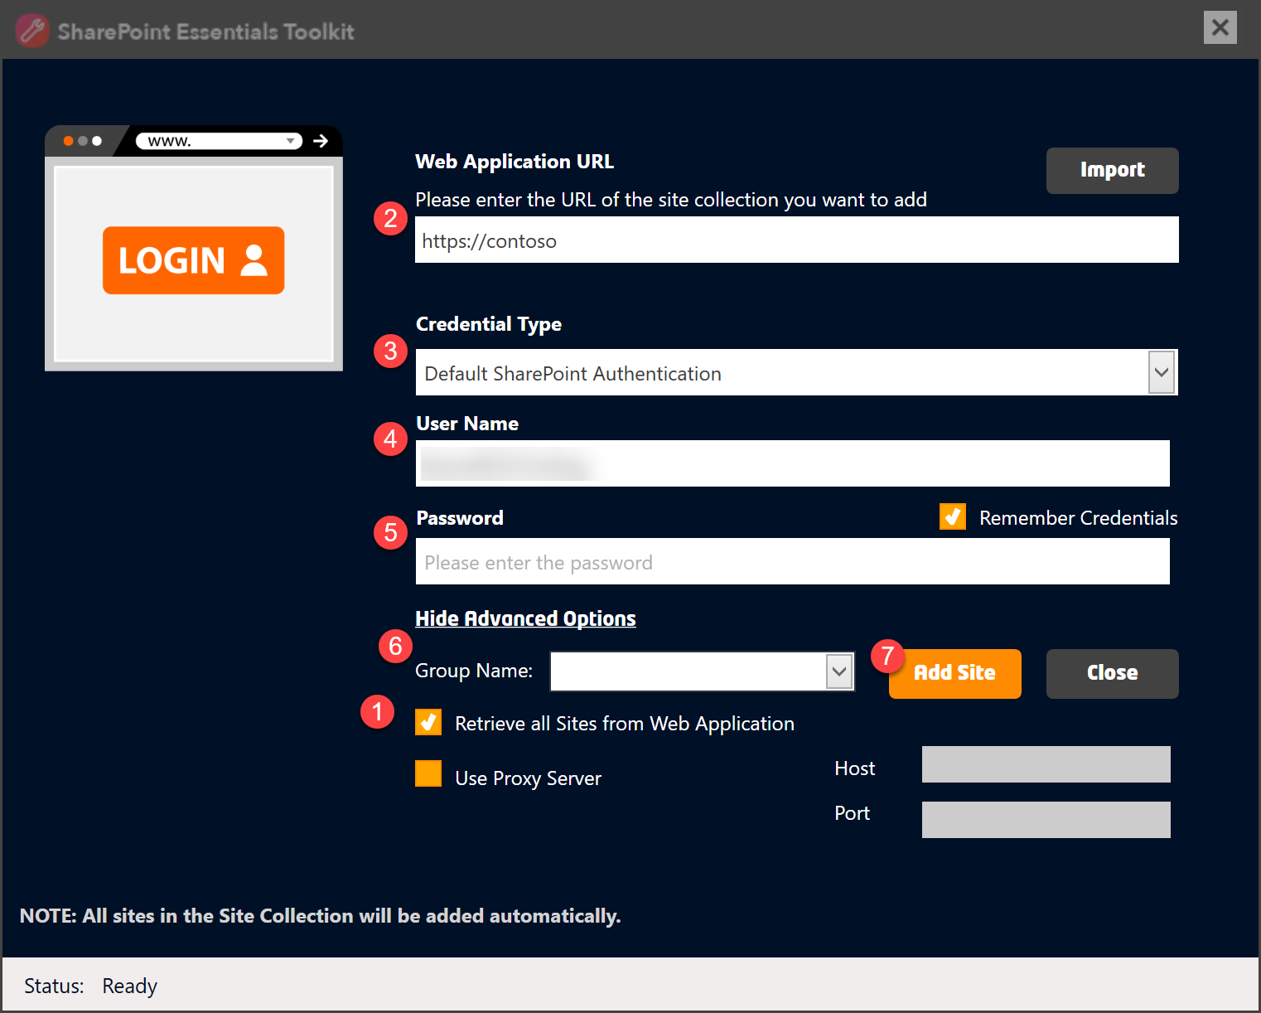
2. Another option is to Import using a MS Excel spreadsheet. To do this, click Add Site from the Home tab, then click the “Import” link. Create a new MS Excel document and add 2 columns, the first column should be “Site URL” and a second column to be “Contact Email” (optional).

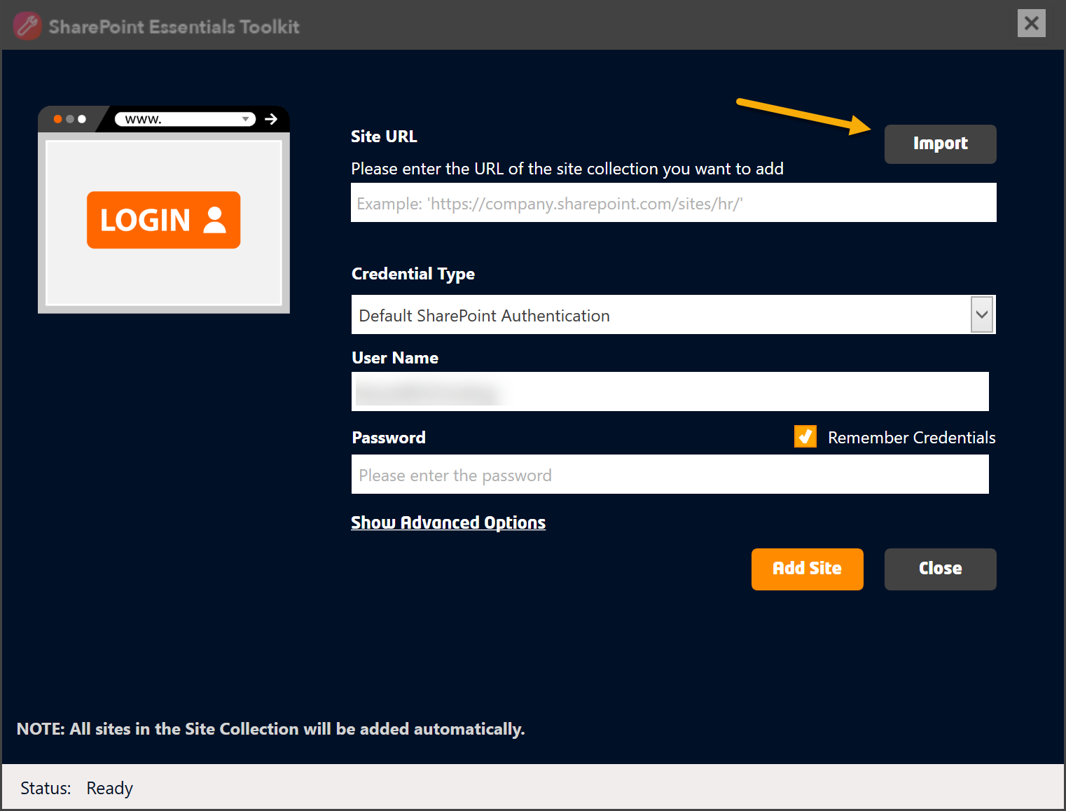

“Site URL” is the URL of the site collection to be added to the Home Page Dashboard.   
“Contact Email” (optional, can be left blank) is the email address of the person who will receive reports for this site via email notifications. See “Contact Email” section below for more information.

**IMPORTANT**: This should be a list of Site Collections to be imported. Any subsites that the account has access to will be imported automatically. You should not import using a list of subsites/SPWebs.

**NOTE**: You can use PowerShell below to get a list of All Site Collections into a CSV file and you only need to import once to get them listed.

### SharePoint On-Premise

*get-spsite -limit all -WebApplication http://yourwebapplication | Select Url | Export-CSV "C:\Users\yourusername\Documents\spsites.csv"*

### SharePoint Online (Office 365)

Download and install the SharePoint Online Management Shell:   
<https://www.microsoft.com/en-us/download/details.aspx?id=35588>

<https://technet.microsoft.com/en-us/library/fp161372.aspx>

#Connect to SPO  
*$AdminUrl = “*[*https://tenant-admin.sharepoint.com/*](https://tenant-admin.sharepoint.com/)*”  
$UserName = “*[*username@tenant.onmicrosoft.com*](mailto:username@tenant.onmicrosoft.com)*”  
$userCredential = Get-Credential -UserName $UserName -Message "Type the password."  
Connect-SPOService -Url $AdminUrl -Credential $Credentials*  
  
#Get Site Collections in tenant  
*$sites = Get-SPOSite | Select Url | Export-CSV "C:\Users\yourusername\Documents\spsites.csv"  
#Retrieve and print all sites  
foreach ($site in $sites)  
{  
 Write-Host $site.Url  
}*

## Adding Additional Sites

After you have added sites to the Home Page Dashboard and need to add additional sites, use the “Add Site” button on the Left Navigation to add the additional subsites. The tool will not replace existing sites or the reports if they are already present in the toolkit, they will detect existing sites based on the site URL and site GUID and update the username/password credentials if they have changed.

## Deleting Multiple Site Collections (from Home Page Dashboard)

Sometimes you may need to remove multiple Site Collections from the Home Page Dashboard.

### SharePoint Essentials Toolkit v8.8.0.0 and above

Select each Site Collection you would like to delete from the Home Page Dashboard and click “Delete”.

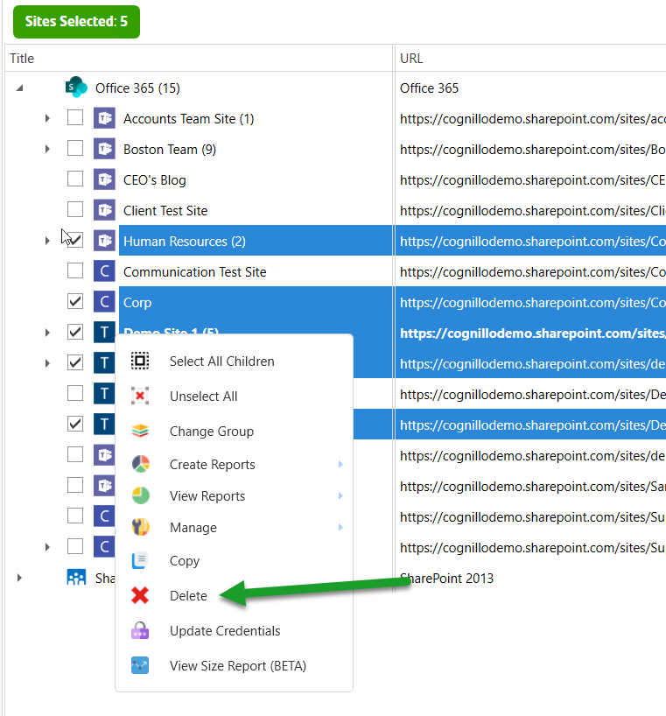

You will prompted to confirm deletion, click Yes.

Optionally, you can choose to delete the related logs and reports (stored on the computer).

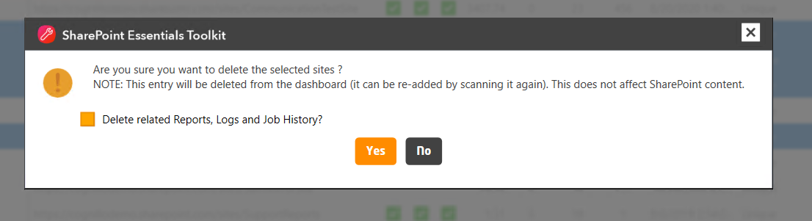

### SharePoint Essentials Toolkit v8.6.4.0 and below

To do this, you could select one Site Collection at a time and right click->Delete, however if you have more than 5 Site Collections to delete, this could take a while.

1. Select the root Site Collection nodes from the Home Page Dashboard  
   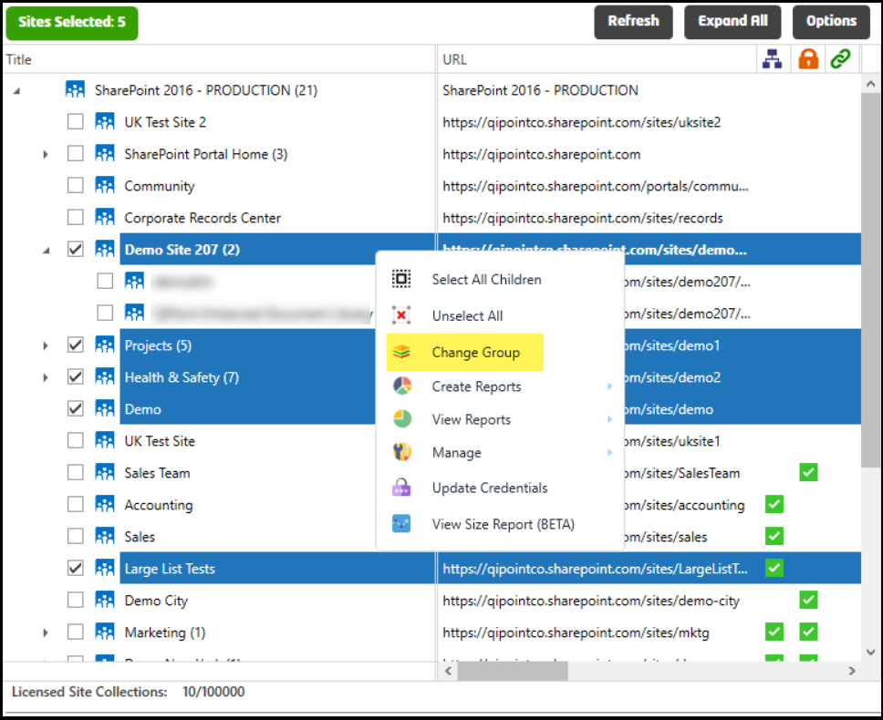
2. Right click->Change Group
3. Call this Group ‘To Delete’
4. After the sites are moved to that group, right click the group and select “Delete”

## Syncing Sites in Home Page Dashboard

You can right click a node and select ‘Refetch Sites’ to re-sync with SharePoint. This will add new sites under the selected site. If any sites have been deleted, they will still remain in the SharePoint Essentials Toolkit so that the user may still view their reports. Deleted sites will be marked with a **Red X icon** in the Home Page Dashboard.

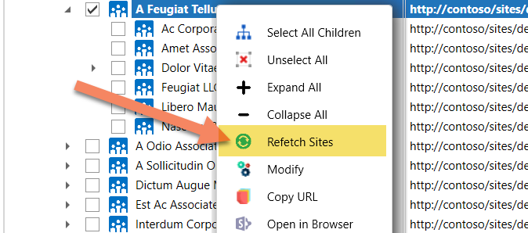

## Contact Email

The Contact Email column in the Home Page Dashboard is proprietary to this tool. It is used to send email notifications to users who are responsible for the site. This is optional and the email address can also be defined manually per job.

If an email is specified in this column for a site, you can enter “<Contact Email>” in the Email Recipient area of the report (instead of an actual email address). The report will then look up the value in this column for that site.

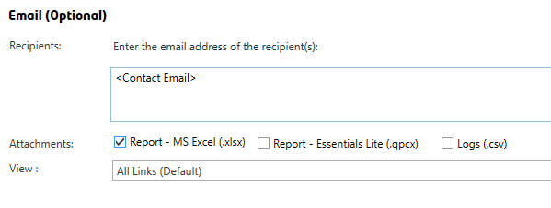

This will then use the value for the corresponding site being scanned, the tool will retrieve the email value from ‘Contact Email’ (below)

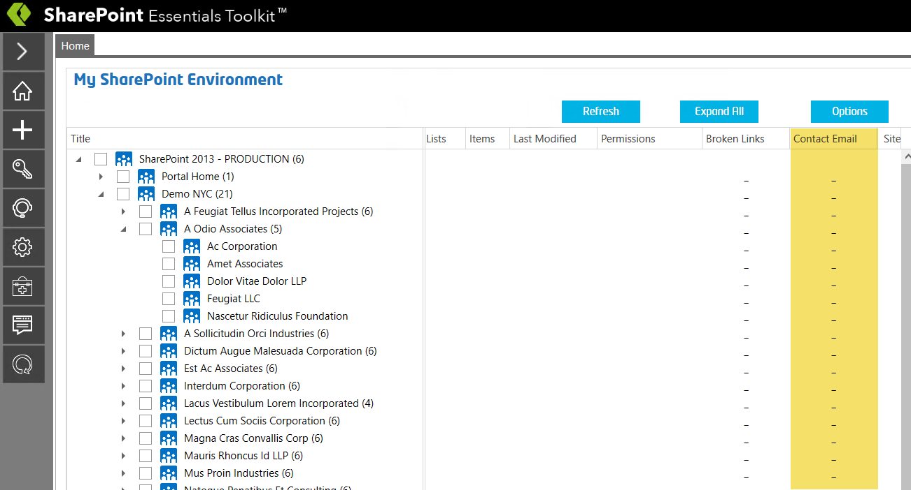

NOTE: By default, reports are not emailed, you must configure the Email (SMTP server) settings in the Settings page, then add the email address of the email recipient in the corresponding report job (if you want to use the special keyword <Contact Email> as described above.

## Managing Sites on the Home Page Dashboard

The user can customize the group and category names, such as adding a group for “Production” and “Test Sites”.

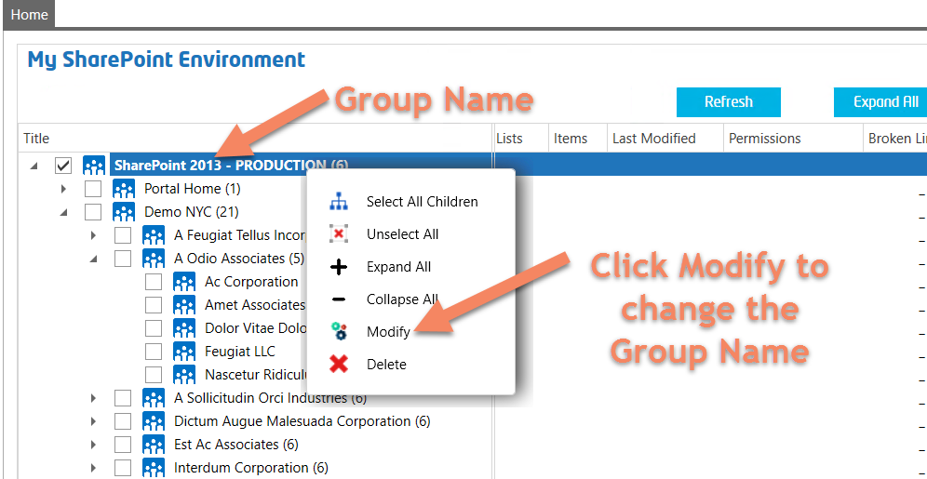

Enter the new name of the group and select an icon for the group

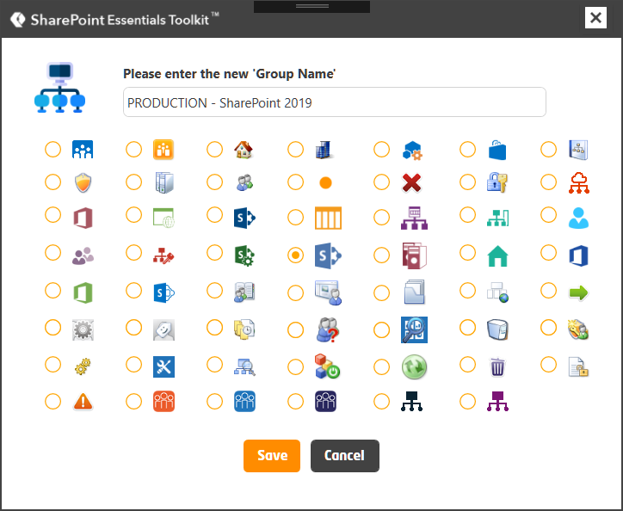

The new name and icon will now appear for that group

You can also change the group of a Site Collection and all sites under it by selecting one or more Site Collection nodes, then right clicking and selecting “Change Group”

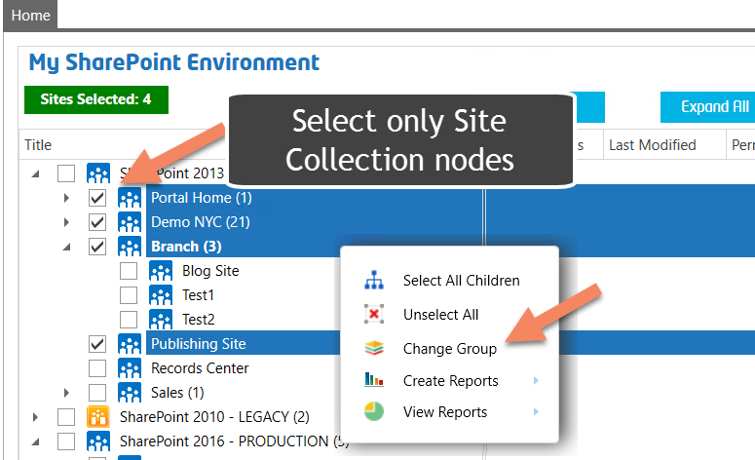

Click Save and you should now see a new group for the Site Collection

## Changing Group for Multiple Sites

You can change the group of multiple Site Collections and sites by selecting the top root sites/nodes and then right clicking and selecting ‘Change Group’. If you have any Main Groups or sub sites selected will hide the ‘Change Group’ option.

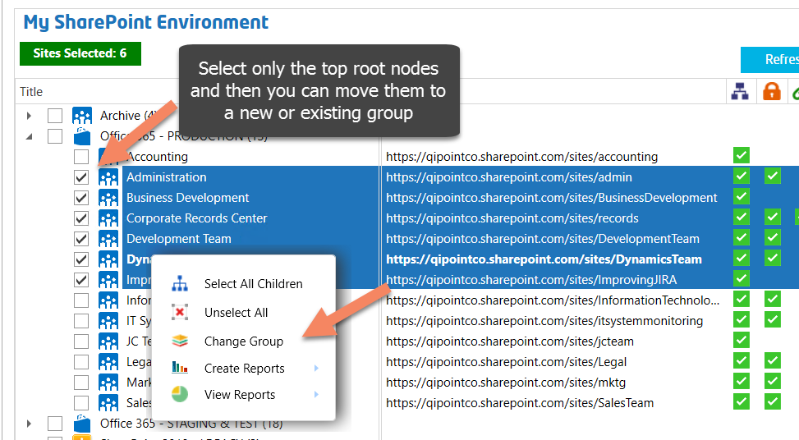

## Executing Tasks from the Dashboard

You can execute tasks from the Dashboard such as Finding all Large Files or Files with too Many Versions, or All Broken Links in a Site by right clicking on the site you want to perform the task on, or by selecting the sites you want to run a Job for, then use the Quick Actions Panel or right click ‘Create Reports’ ‘Copy’ ‘Manage’ etc to perform an action.

## What is the Red dot on some site icons?

After adding sites to the Home Page Dashboard, you may notice some of them have a red dot in the lower right corner, this denotes that the site has ‘Unique Permissions’ (vs. inherited from parent).

This value is real-time. If you select the site, the data is re-retrieved from the live SharePoint site to ensure it has up to date information for this value/setting.

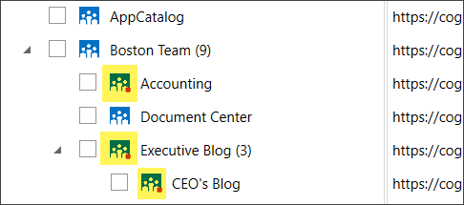

## Site Titles or information out of sync?

If some of the information in the Home Page Dashboard such as Title or List Count seem old or incorrect, use the ‘Refresh button in the Home Page Dashboard to refresh the data. If this does not resolve the issue, right click the site which is having an issue and click “Refetch Sites”, this will automatically update the information for the site and all of its sub sites.

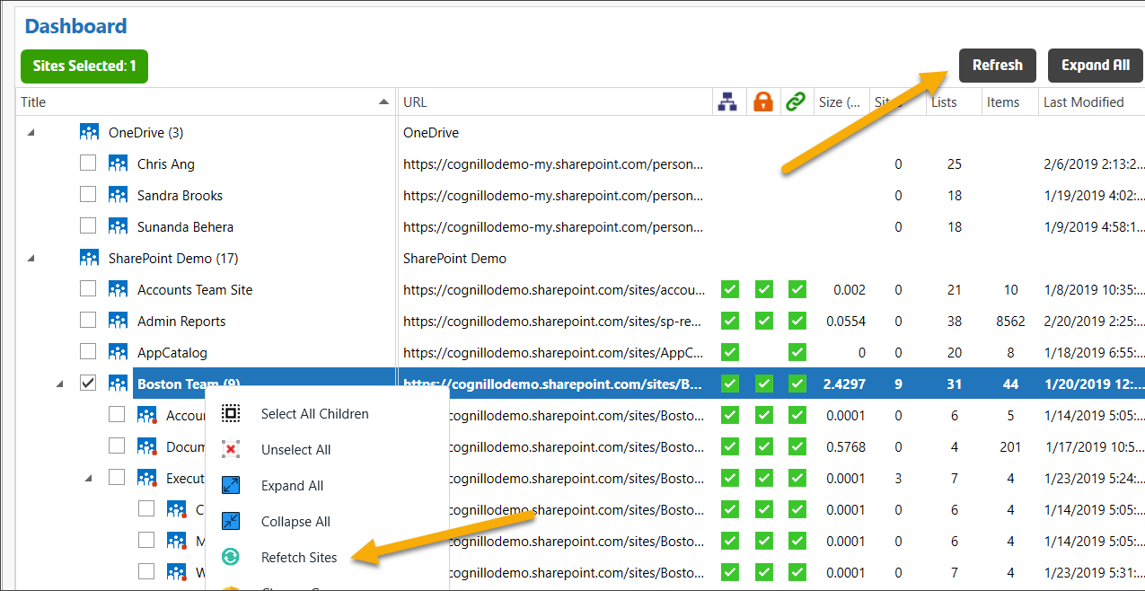

## Batch Processing Jobs for Multiple Sites

In addition to bulk importing multiple sites (see Import Multiple Sites to Dashboard), you can also execute jobs against multiple sites at once. To do this, select multiple sites from the Home Page Dashboard. You can also Right Click->Select all Children to select a site and all its subsites. You can also hold SHIFT and select a site range by selecting a site, then select a site below it while holding SHIFT to automatically select all sites between them.

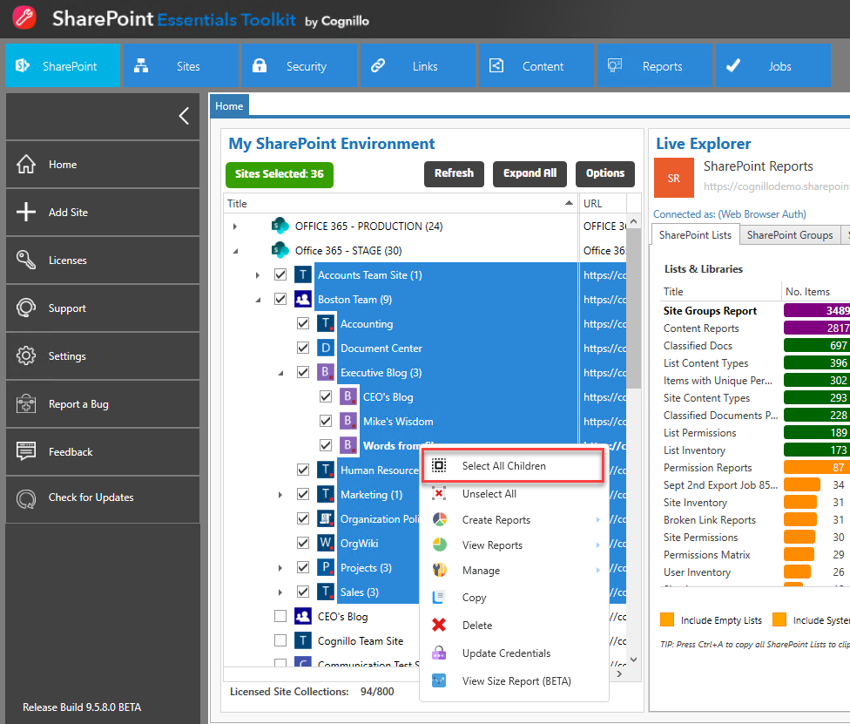

Right click and you will have the option to “Create Reports”

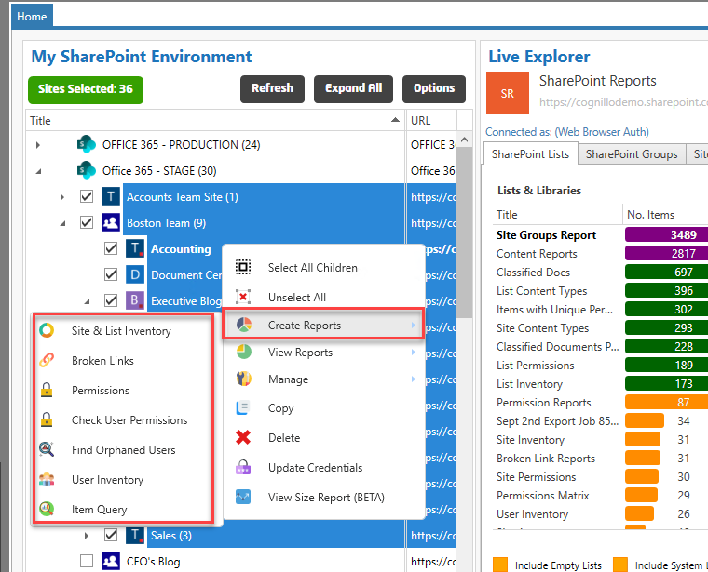

Click to create one of the reports, you will see the Job Options window appear.

Below is an example of the Site Audit report that will run against multiple sites that we selected earlier, notice the URL shows “Sites Selected: 36”

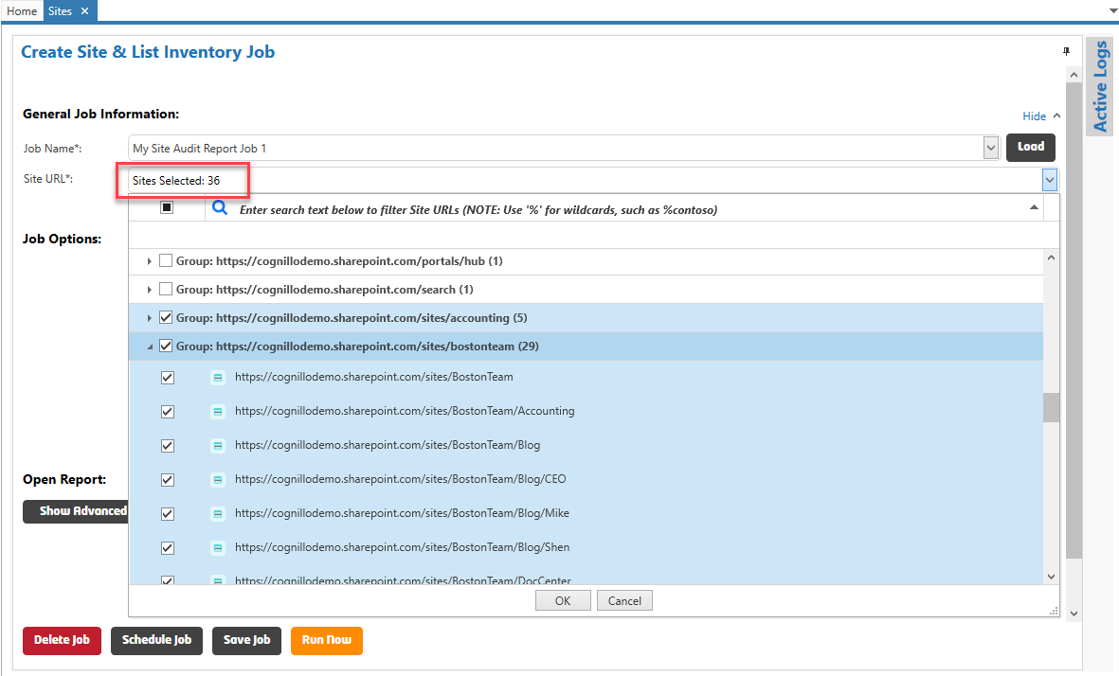

You can choose to run it immediately (Run Now) or at a later date/time (Schedule Job):

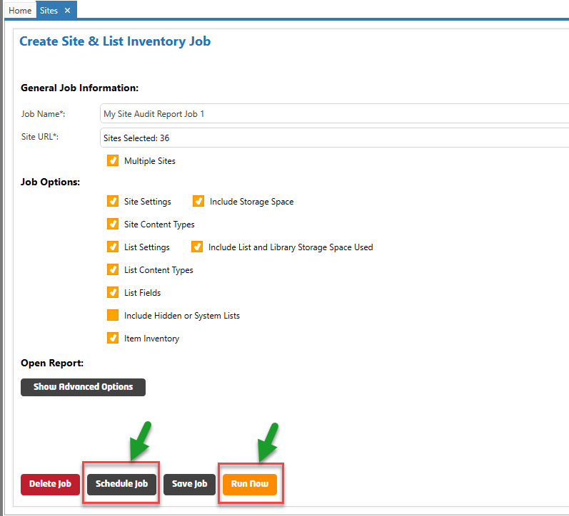

You may choose to Run all jobs immediately or on a schedule. Once you click “Schedule Job”, the Scheduler Window will appear for you to choose appropriate settings.

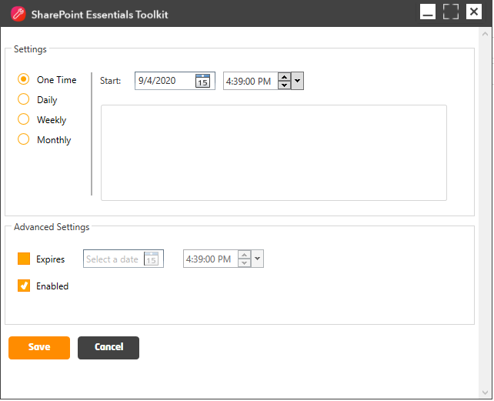

If you click “Run Now” and multiple Sites are selected, a separate Job will be created for each Site so that they can be run in parallel to complete faster.

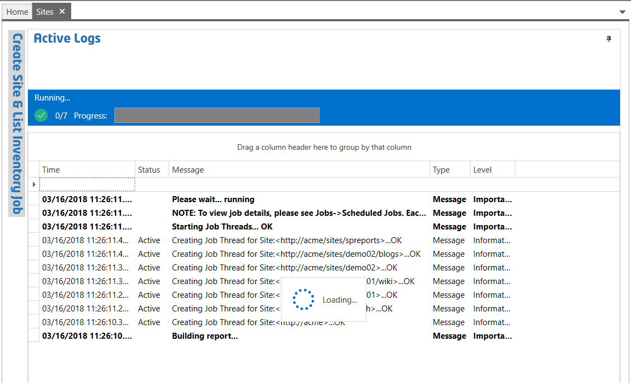

Above you can see 7 jobs for each of the 7 sites selected. Once a Job is complete, you will see the status change from Active to Done.

If one or more of the 7 jobs complete, the ‘Open Report’ button will appear to allow you to review the report for the information collected thus far.

The Progress Bar and job status count will be updated automatcially:

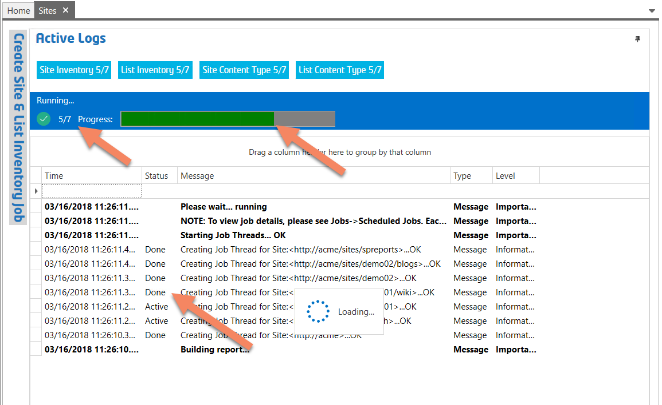

Once the entire job completes, the user will be notified with a pop up window. See the following section for details.

## Job Completion Notifications

Once the job completes, the user will be notified with a pop up window:

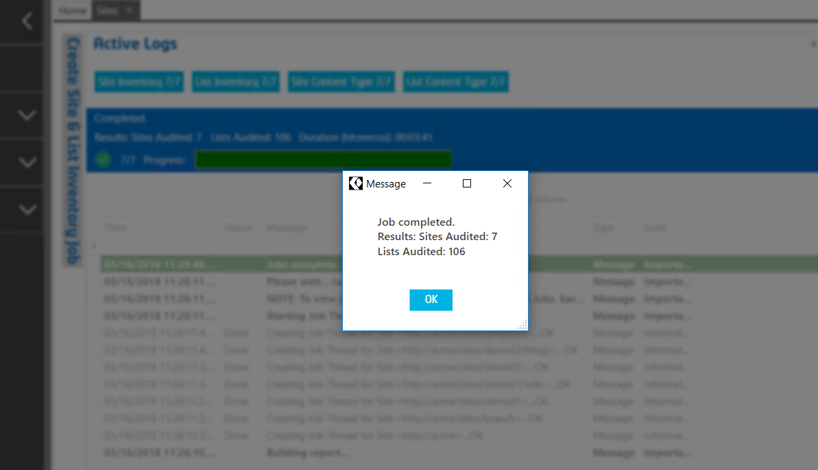

If the SharePoint Essentials Toolkit is minimized, a less intrusive pop up window is used to avoid interrupting user if they are working on something:

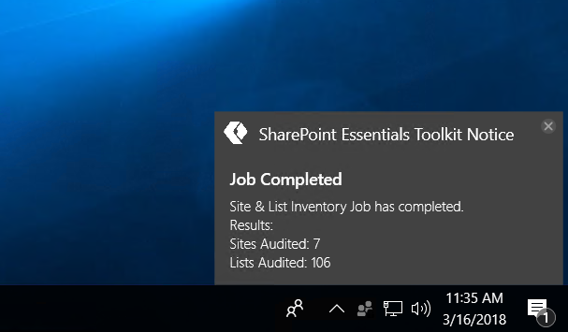

The user may also configure an email notification to be sent to them to alert of job completion:

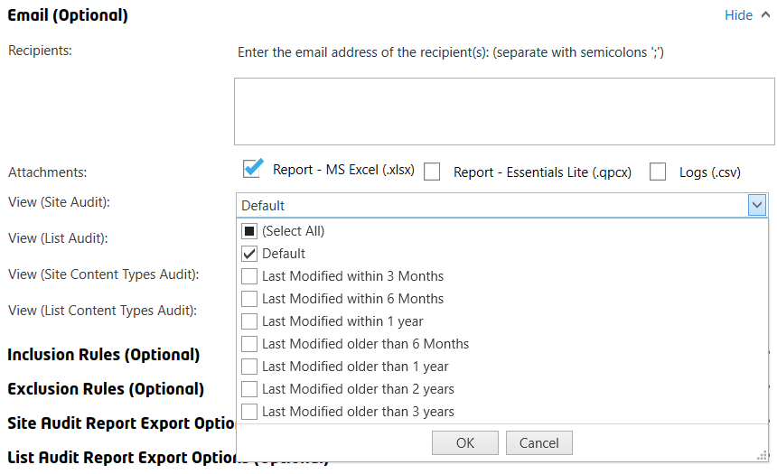

# Jobs

You can access job information by clicking on the “Job” button in the Top Navigation



## Job History

You can view all job history by clicking on the “Job History” button in the Left Navigation

## Scheduled Jobs

You can view all scheduled jobs by clicking on the “Scheduled Jobs” button in the Left Navigation

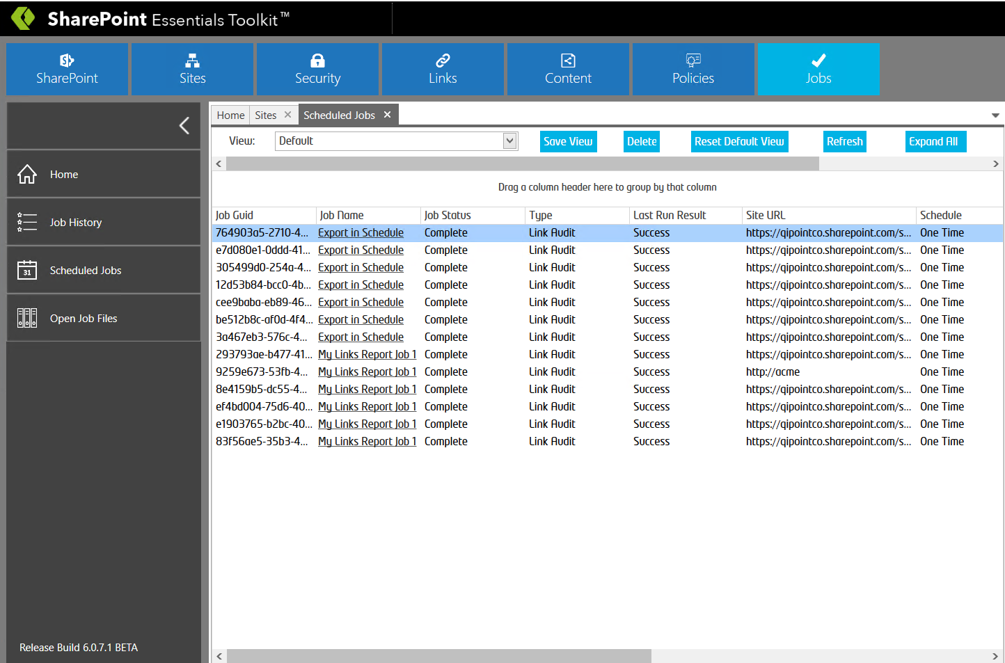

**TIP:** Ensure the “SharePoint Essentials Service” (Windows Service) is running before trying to schedule a job. Ensure the user account used to run the service has ‘Modify’ permission on folder C:\ProgramData\Cognillo (NOTE: This is a hidden path; you can paste C:\ProgramData into the address bar in Windows Explorer to access it) this is where the scheduler job information is stored. By default, all users should have read and edit rights as this is set when the program is installed.

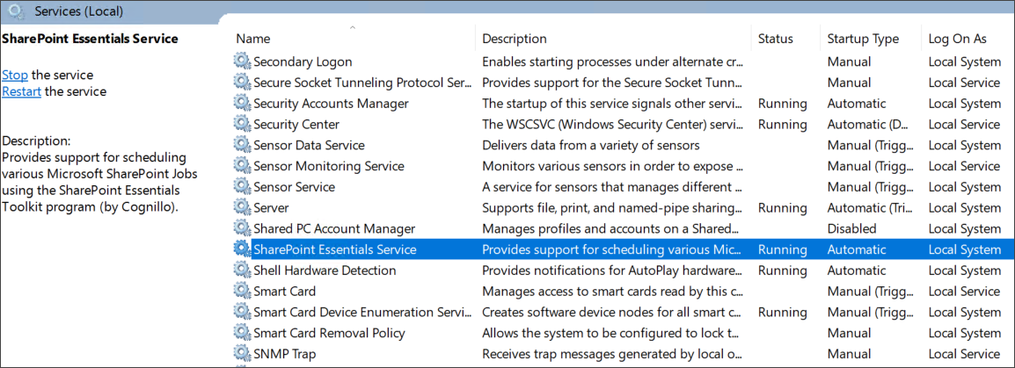

# Licensing

## Components

The SharePoint Essentials ToolkitTM by Cognillo may have multiple components activated to provide more functionality.

To view what components are installed, on the ribbon, click Home -> Licenses.

## License Model

The SharePoint Essentials Toolkit and components are licensed in one of two ways:

1. Per Seat or Named User
2. Concurrent (Floating) Licenses

Please contact us for further information.

## Modifying the Site Collections that are licensed

You may need to change or remove a Site Collection license and may do so by going to the component license page, selecting the Site Collection you wish to remove (and free up), and click ‘Delete Site Licenses’, this will remove the Site Collection License from use.

By default, this section will be disabled. You will need to contact us to Enable the modification of Site Collections.

Reports and logs will not be removed but will not be accessible from the product user interface and must be opened using Windows Explorer and a compatible program such as MS Excel or Notepad.

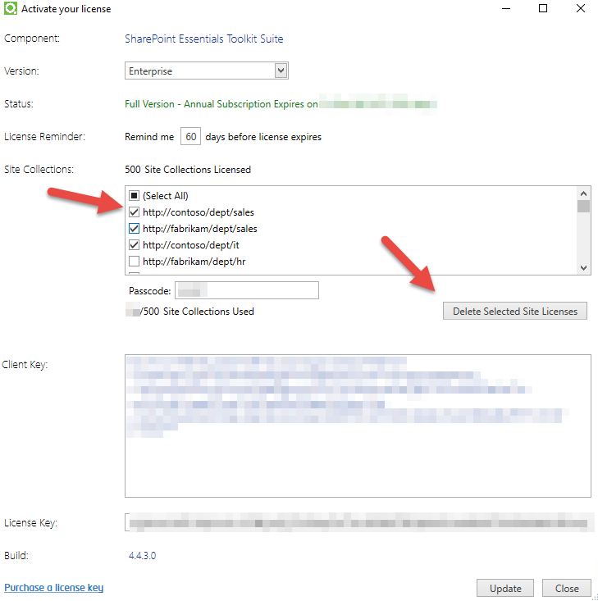

## Obtaining a License

There are three ways you can purchase a license

1. Online: visit <https://www.cognillo.com>
2. Call us at 1-855-747-6468
3. Email us at [sales@cognillo.com](mailto:sales@cognillo.com)

You may place your order and receive a license key with a company issued Purchase Order or Credit Card.

## Transferring a License

You may need to transfer the license if the machine was lost, stolen, re-formatted, or if you would like to assign a license to another user. [Contact us](https://cognillo.atlassian.net/servicedesk/customer/portal/2/group/2/create/10) to obtain a new license activation key.

## Auto-Deactivate Cloud License

Auto-deactivate is used to automatically release a cloud license back to the pool so that other users can use the cloud license.

In the Settings page, there are 2 options for auto-deactivate.

1. **Auto-deactivation (Hrs):** The license will be released from client machine automatically after a preset amount of time has passed (in hours). Decimals (minutes) are also supported such as 0.5. The application may be closed at this time and the tool will still release the license (via Windows Service called “SharePoint Essentials Service”)
2. **Auto-deactivate on Close**: The license will be released from the client machine when the tool is closed (clicking the ‘x’ on top right of tool). Auto-deactivate on close does not work if the application crashes or if the process is terminated (such as through Task Manager).

For auto-deactivation to work, the following criteria must be met, or the license will not get auto-released:

1. There must be at least 1 job present in Job History
2. There must not be any enabled scheduled jobs set for in the future
3. There should be no jobs actively running
4. Windows service ‘SharePoint Essentials Service’ must be running

If the criteria above is true, then the time set in the Settings page will start to count down.

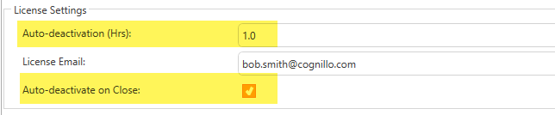

## Manually Deactivate a Cloud License

An alternative to the ‘Auto-deactivate’ options above, is to manually deactivate using the ‘Deactivate’ license button.

The “Deactivate” button will manually release the license back to the pool, this is in the License Page:

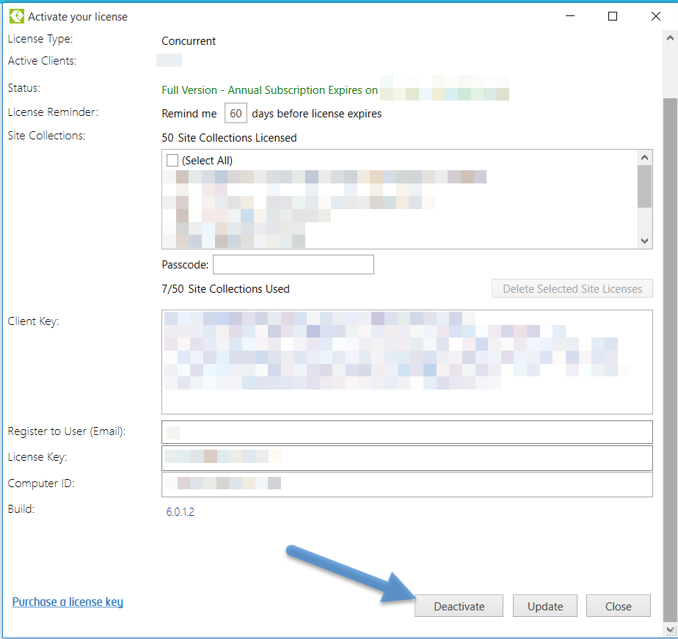

## Re-Activating a Cloud License

If the product license is ‘Deactivated’, and the user opens the program to run a report/job, they will be prompted to ‘Re-Activate’ the license.

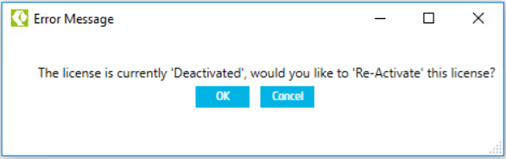

If a license is available, the product will consume 1 user cloud license. If no licenses are available, the user will then see an error pop up message stating that the maximum number of licenses are used.

# Tips, Comments & Troubleshooting

* The utility can be paused to view the active logs and re-started as needed
* Sometimes it may appear a scan/job is hanging and stuck on “Scanning”. This is because the application is waiting for a response from the server which could potentially be for a large set of data. This may potentially take up to 15 minutes at times if the dataset being retrieved is large. Typically, regardless of the SharePoint environment, this ‘waiting’ should not happen often nor should it take longer than 5-10 minutes. If you encounter issues please contact us as it may be due to misconfiguration or the program is having trouble accessing files which we may be able to help resolve.
* If you have trouble accessing sites or you encounter

“The remote name could not be resolved”

Your machine may have lost connection to the site (it is having trouble resolving the site URL), you can follow these commands to get your machine to find the site again:

* + From the Start menu
  + Click Run and type “cmd” (or search for ‘Command Prompt’ from the apps page)
  + In the Command prompt window, type “ipconfig /flushdns” and press enter
  + Wait a minute and you should be able to browse and resolve the remote name (web site) correctly if it exists
  + Close the Command prompt window
* Users with READ rights get an error when trying to retrieve sub site data:

“There was a problem enumerating sub sites. Details: Access denied. You do not have permission to perform this action or access this resource.”

Users require “Browse Directories - Enumerate files and folders in a Web site using SharePoint Designer and Web DAV interfaces.” rights. You can add this permission from Permission Levels in Site Settings -> Site Permissions.

* If you encounter:

“Could not load file or assembly 'Microsoft.IdentityModel, Version=3.5.0.0, Culture=neutral, PublicKeyToken=31bf3856ad364e35' or one of its dependencies. The system cannot find the file specified.”

There may be a .NET framework component missing. Please download and install the Windows Identity Foundation component at <http://www.microsoft.com/en-us/download/details.aspx?id=17331>

* ONLY APPLIES TO Office 365: In some cases, if the Office 365 SharePoint site address/domain being resolved is using a CNAME, an error can occur in the tool “Forbidden” or “The communication object, System.ServiceModel.Channels.ServiceChannel, cannot be used for communication because it is in the Faulted state”. To resolve this issue, use the SharePoint Office 365 address for the portal when performing the scan, such as <https://myportal.sharepoint.com> . If you encounter this issue, use “Web Browser Authentication”
* If you receive errors of missing features when running a scan, this may be due to faulty features installed on the farm/site. The tool tries to retrieve information from a list/library and items in order to parse the contents within them. When a feature is missing or corrupted, the tool may report an error. This response is from the SharePoint API. To resolve this, find the missing/corrupt features and reinstall them or remove them from the site/farm.
* Scheduler Issues - If you encounter errors while trying to schedule jobs, you can try deleting the Scheduled Jobs folder located at “C:\ProgramData\Cognillo\Scheduled Jobs”.

NOTE: This path is hidden so you should copy and paste this path into Windows Explorer. Also, you will need to recreate scheduled jobs if you delete this folder.

# Technical Support

If you need technical assistance, please use the link below to contact us!

<https://www.cognillo.com/support>

We are here to help!